Kevin Burgess: Recent Publications and Patents

Co-author of the monthly Highlights in Chemistry and Industry since 1986;

now contributing the Biomedical section

H index 82 (Google Scholar) as of July 2022

ORCID ID: 0000-0001-6597-1842

Complete List of Published Work in MyBibliography:

https://www.ncbi.nlm.nih.gov/myncbi/1tINkobI4_pIps/bibliography/public/

https://scholar.google.com/citations?user=0xlRve0AAAAJ&hl=en

Publications

2023

355. The Unrealized Potential of Small and Mid-sized GDNF-family Mimics, T. Pewklang, T. Thompson, A. Kamkaew, B. Zhu, R. Morey, C. S. de Paiva, K. Burgess, Chem. Soc. Rev., 2023, submitted.

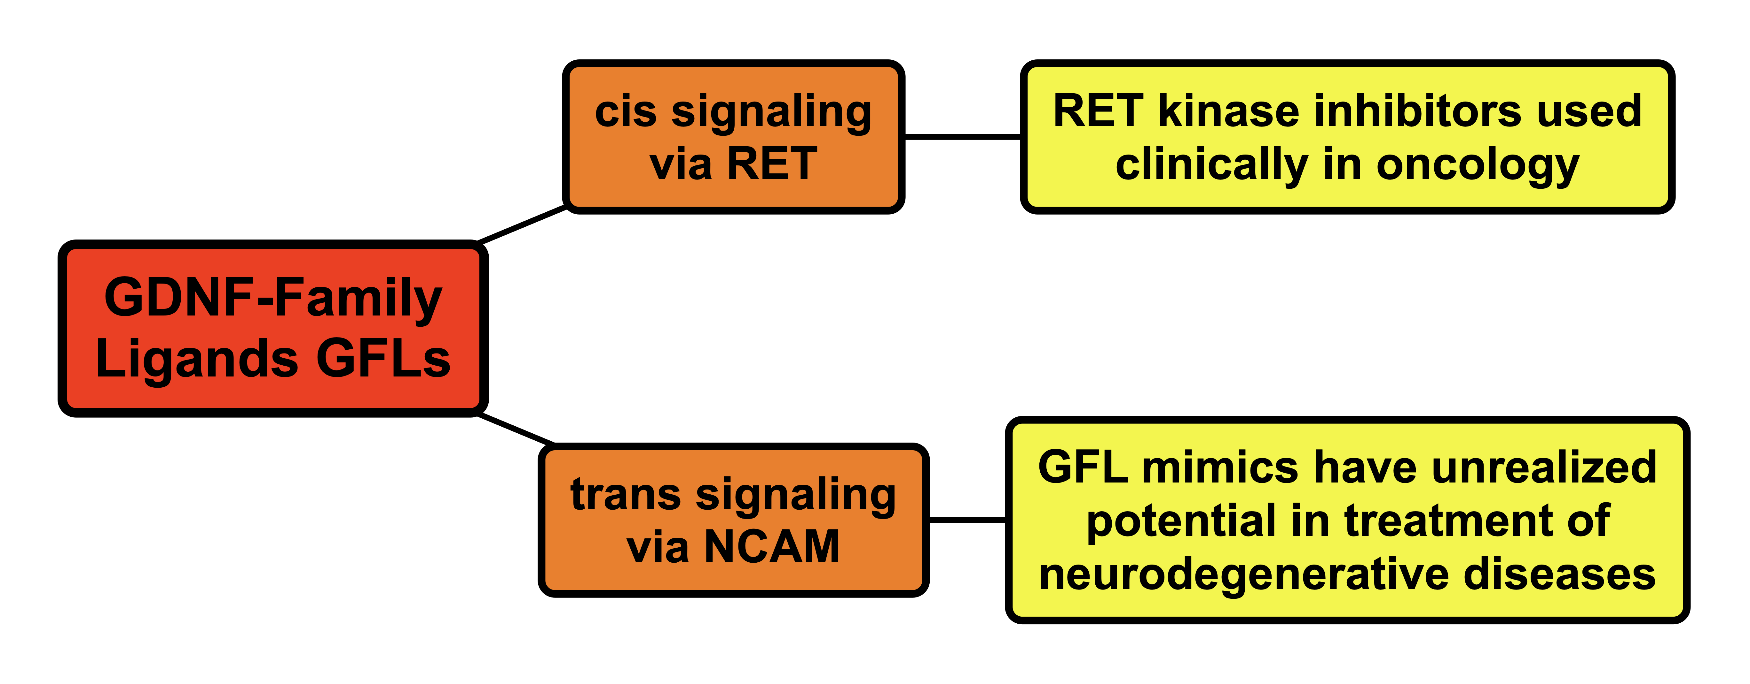

354. Bioinformatics Leading to Conveniently Accessible, Helix Enforcing, Bicyclic ASX Motif Mimics (BAMMs), T. Mi, D. Nguyen, K. Burgess, Nat. Comm., 2023, submitted.
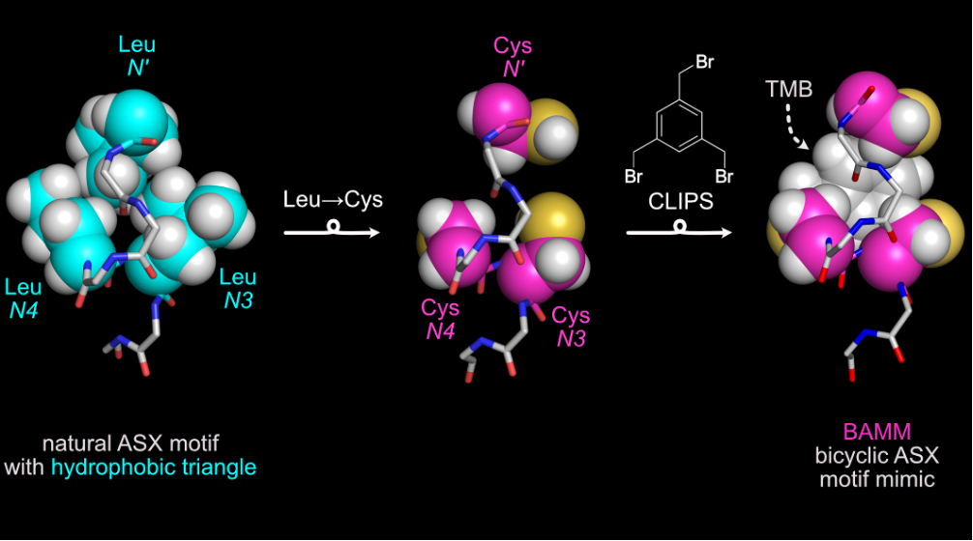

353. Streamlined Protein-protein Interface Lop Mimicry, T. Mi, S. Siriwibool, K. Burgess, Angew. Chem., 2023, submitted.

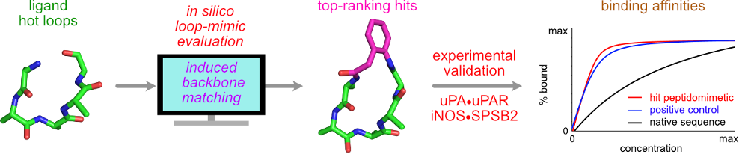

352. Recent Development of Nanomaterials for Transdermal Drug Delivery, M. Y. Leong, Y. L. Kong, K. Burgess, W. F. Wong, G. Sethi, C. Y. Looi, Biomedicines, 2023, 11, 1124 (biomedicines11041124).

351. Novel near-infrared Aza-BODIPY-based fluorescent and colorimetric sensor for highly selective detection of Au³⁺ in aqueous media, human skin and brain cells, D. Plaisathit, K. Setthakarn, J. Sirirak, A. Kamakew, P. Maitarad, K. Burgess and N. Wanichacheva, J. Photochem. Photobio. A., 2023, 441, 114713 (j.jphotochem.2023.114713).

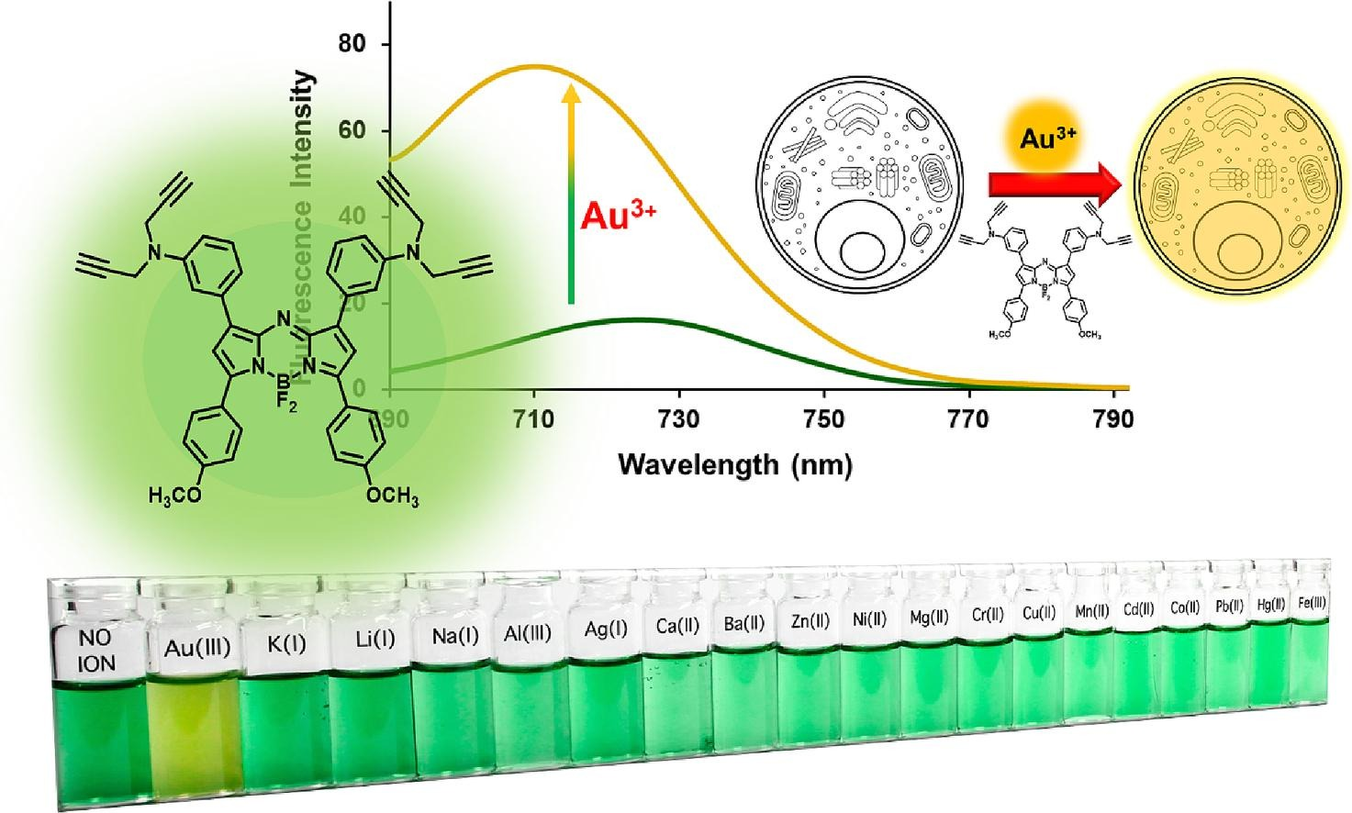

350. Bicyclic Schellman Loop Mimics (BSMs): Rigid Synthetic C-Caps For Enforcing Peptide Helicity, T. Mi, D. Nguyen, K. Burgess, ACS Cent. Sci., 2023, 9, 300-306 (acscentsci.2c01265) PMID: PMC9951308.

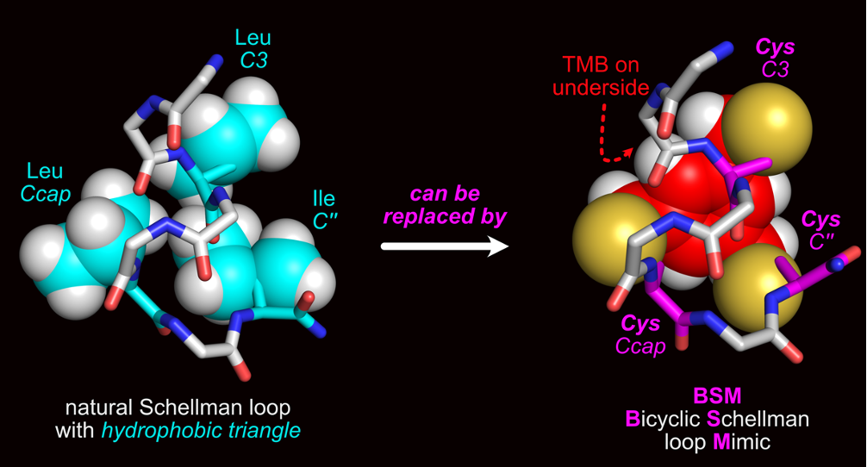

349. Cytoxins of Tumor Seeking Dyes: Impact on Future Clinical Trials, S. M . Usama, Z. Gao, M. Arancillo, K. Burgess, ChemMedChem., 2023, e20200561 (cmdc.202200561).

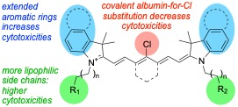

2022

348. A, B, C’s of Trk Receptors and Their Ligands in Ocular Repair, A. Gupta, J. G. Galletti, Z. Yu, K. Burgess, C. S. de Paiva, Int. J. Mol. Sci., 2022, 23, 14069 (ijms232214069).

347. Piptide Chemotypes For Perturbation Of The Interaction Of Urokinase With Its Receptor, M. Arancillo, C. M. Lin, K. Churion, K. Burgess, J. Med. Chem., 2022, 65, 12925 - 12932 (acs.jmedchem.2c00759)

346. New, Potent, Small Molecule Agonists of Tyrosine Kinase Receptors Improve Dry Eye Disease, Z. Yu, S. Joy, T. Mi, G. Yazsanpanah, K. Burgess, C. De Paiva, Front. Med. Ophthal., 2022, 9, 937142, (10.3389/fmed.2022.937142).

345. Synthetic Helical Peptide Capping Strategies, J. Whisenant, K. Burgess, Chem. Soc. Rev., 2022, 51, 5795 – 5804 (10.1039/d1cs01175h).
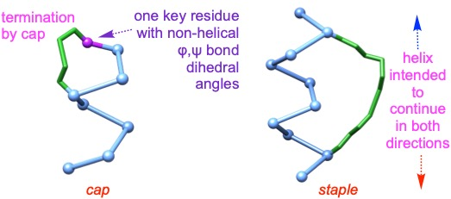

344. QuatCy-I₂ And MHI-I₂ In Photodynamic Therapy, S. Thavornpradit, S. M. Usama, G. K. Park, H. S. Choi, K. Burgess, ACS Med. Chem. Lett., 2022, 13, 470-474 (acsmedchemlett.1c00640).

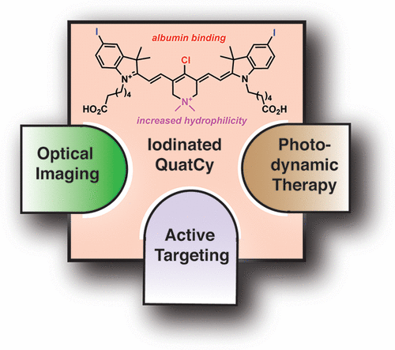

343. A Fluorescent PARP Inhibitor Applied To Intracranial Glioblastoma: Accumulation And Persistence In Vivo, Z. Gao, Z. Yang, Z. Li, K. Burgess, ACS Med. Chem. Lett., 2022, 13, 911-915, (acsmedchemlett.1c00712).

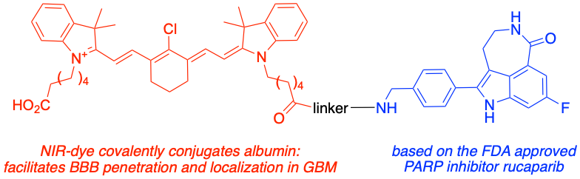

343. Antibody-Dependent Cellular Phagocytosis of Tropomyosin Receptor Kinase C (TrkC) Expressing Cancer Cell for Target Immunoterapy, P. S. Lai, S. M. Usama, L.-V. Kiew, H. B. Lee, L. Y. Chung, K. Burgess, C. S. Kue, Cancer Immunol., Immunother., 2022, 71, 2099-2018, (10.1007/s00262-022-03147-y).
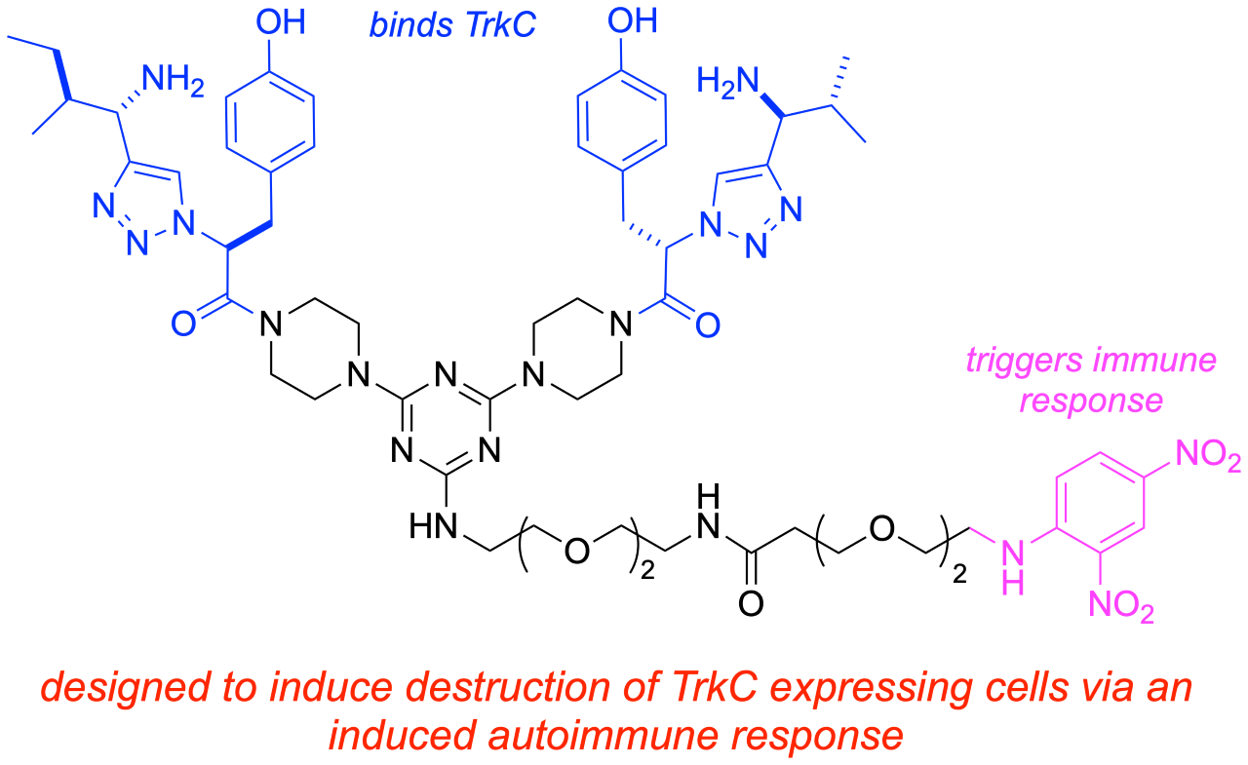

341. Small Molecule Peptidomimetic Trypsin Inhibitors: Validation Of An EKO Binding Mode, But With A Twist, R.-L. Lyu, S. Joy, C. Packianathan, A. Laganowsky, K. Burgess, Org. Biomol. Chem., 2022, 20, 2075-2080 (10.1039/D1OB02127C).
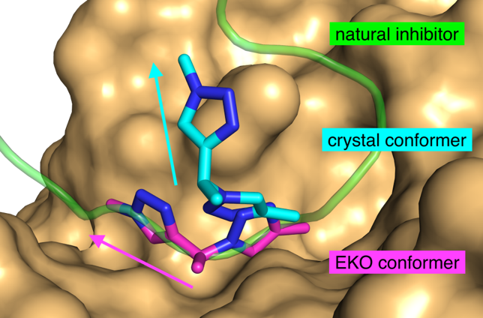

2021

340. Fluorescent Kinase Inhibitors1 As Probes, S. M. Usama, B. Zhao, K. Burgess, Chem. Soc. Rev., 2021, 50, 9794-9816, (10.1039/d1cs00017a).
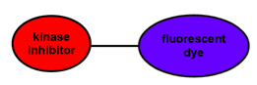

339. Hows and Why of Tumor Seeking Dyes, S. M. Usama, K. Burgess, Acc. Chem. Res, 2021, 54, 2121-2131, (acs.accounts.0c00733).
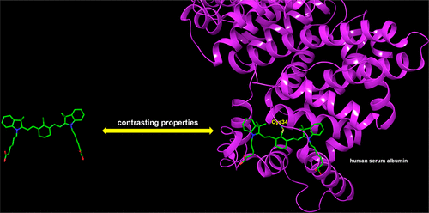

338. Flavylium-, And Silylrhoda-polymethines In Excitation Multiplexing, C. Tian, K. Burgess, ChemPhotoChem, 2021, 5, 1-4, (cptc.202000287)
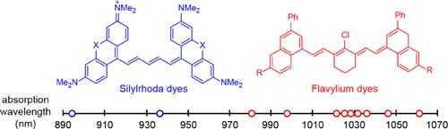

337. Preparation of Nano-ZrO2 Powder Via a Microwave-Assisted Hydrothermal Method, M. Guo, G. Wang, Y. Zhao, H. Li, K. Tang, Y. Zhao, K. Burgess, Ceram. Int., 2021, 47, 12425-12432, (j.ceramint.2021.01.099)
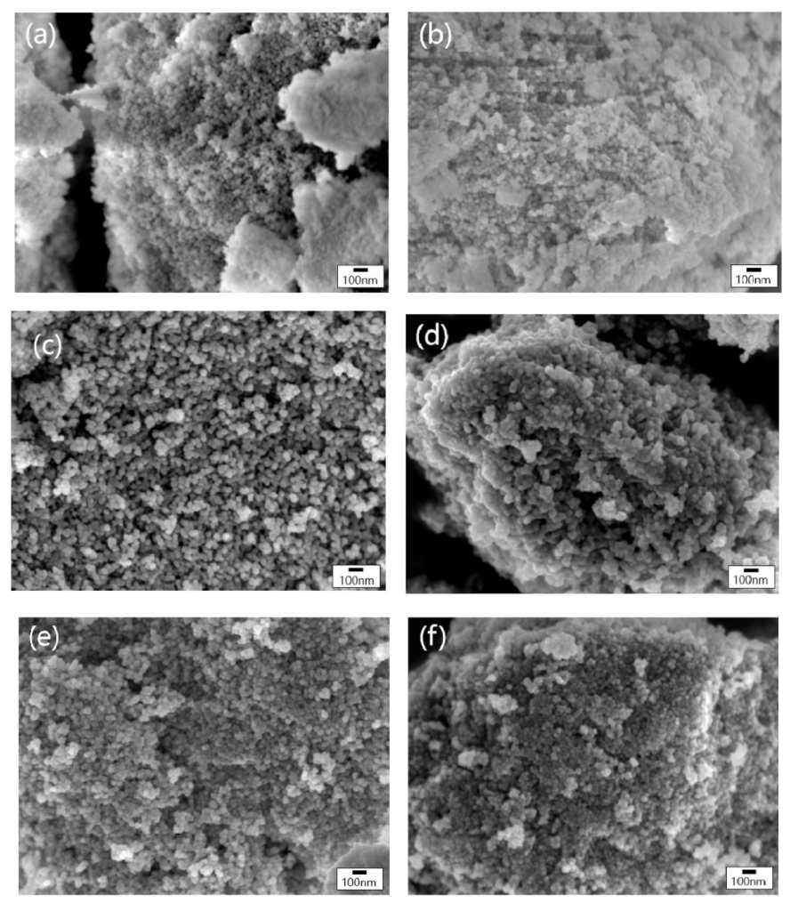

336. PROTAC Compatibilities, Degrading Cell Surface Receptors, and the Sticky Problem of Finding a Molecular Glue, C. Tian, K. Burgess, ChemMedChem, 2021, 16, 316-318. (cmdc.202000683)
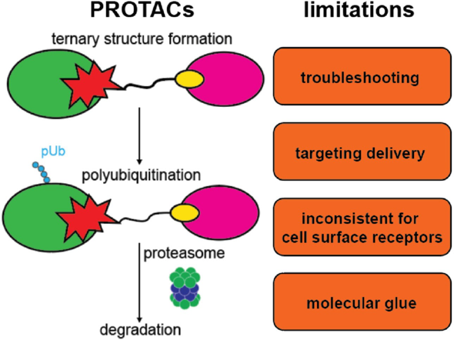

335. Piptides: New, Easily Accessible Chemotypes for Interactions With Biomolecules, M. Arancillo, J. Taechalertpaisarn, X. Liang, K. Burgess, 2020, Angew. Chem. Int., 2021, 60, 6653-6659. (ange.202015203)
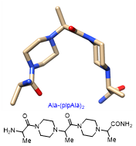

334. Small Molecules Targeting The NEDD8•NAE Protein-Protein Interaction, C.-M. Lin, X. Jiang, K. Burgess, Chem. Sci., 2021, 12, 1535-1543 (D0SC00958J)
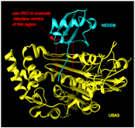

333. Rapid and Visual Detection of Cd2t Based on aza-BODIPY Near Infrared Dye and Its Application in Real and Biological Samples for Environmental Contamination Screening, P. Piyanuch, P. Patawanich, J. Sirirak, K. Suwatpipat, A. Kamkaew, K. Burgess, N. Wanichacheva, J. Hazard. Mater., 2021, 409, 124487. (j.jhazmat.2020.124487)
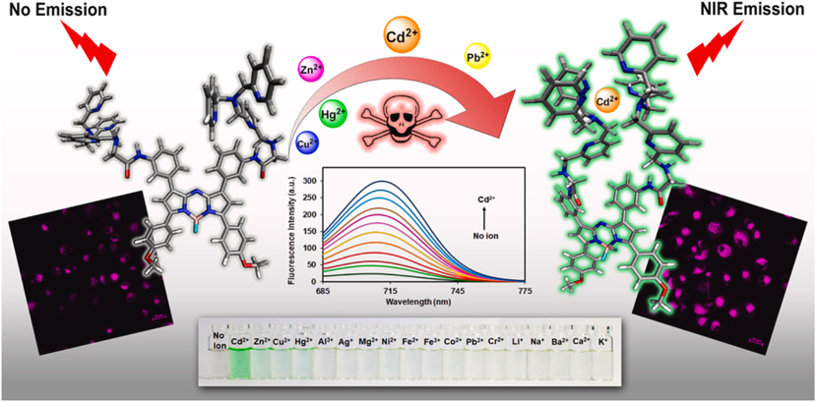

2020

332. Striking Similarities Between CDRs in Some mAbs That Neutralized COVID-19, T. Mi, K. Burgess, ACS Med. Chem. Letters, 2020, 11, 1663-1666. (acsmedchemlett.0c00409)
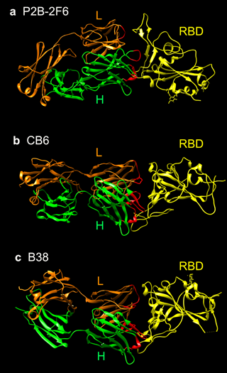

331. Blocking Coronavirus 19 Infection Via the SARS-COV-2 Spike Protein: Initial Steps, J. Whisenant, K. Burgess, ACS Med. Chem. Letters, 2020, 11, 1076-1078. (acsmedchemlett.0c00233)


330. Unconventional Secondary Structure Mimics: Ladder-rungs, C. M. Lin, M. Arancillo, J. Whisenant, K. Burgess, Angew. Chem. Int., 2020, 59, 9398-9402. (anie.202002639)
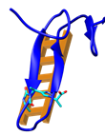

329. Active Targeted Ligand-AzaBODIPY Conjugate for Near-Infrared Photodynamic Therapy in Melanoma, S. Y. Ng, A. Kamkaew, N. Fu, C. S. Kue, L. Y. Chung, L. V. Kiew, J. Wittayakun, K. Burgess, H. B. Lee, 2020, accepted, Int. J. Pharm., 2020, 579, 119189, (j.ijpharm.2020.119189)
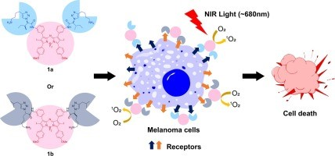

328. Role Of Albumin Binding In Accumulation And Persistence Of Tumor-seeking Cyanine Dyes, S. M. Usama, G. K. Park, S. Nomura; Y. Baek, H. S. Choi, K. Burgess, Bioconjugate Chem., 2020, 31, 248-259, (acs.bioconjchem.9b00771)
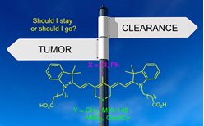

2019

327. TrkC-Targeted Kinase Inhibitors and PROTACs, B. Zhao and K. Burgess, Mol. Pharm., 2019, 16, 4313-4318. (DOI: 10.1021/acs.molpharmaceut.9b00673)
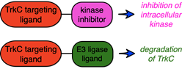

326. Cyanine-Gemcitabine Conjugates as Target Theranostic Agents for Glioblastoma tumor Cells, Z. Jiang, K. Pflug, S. M. Usama, D. Kuai, X. Yan, R. Sitcheran, K. Burgess, J. Med. Chem., 2019, 62, 9236 – 9245. (DOI: 10.1021/acs.jmedchem.9b01147)
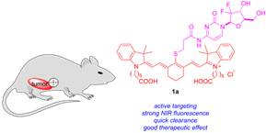

325. Conjugations Of Dasatinib With MHI-248 Has A Significant Advantageous Effect in Viability Assays For Glioblastoma Cells, S. M. Usama, Z. Jiang, K. Pflug, R. Sitcheran, K. Burgess, ChemMedChem, 2019, 14, 1575-1579. (DOI: 10.1002/cmdc.201900356)
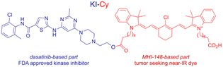

324. Protein Labeling and Albumin Binding Characteristics of the Near-IR Cy7 Fluor, QuatCy, S. Thavornpradit, S. M. Usama, C.-M. Lin, K. Burgess, Org. Bio. Chem., 2019, 17, 7150-7154. (DOI: 10.1039/C9OB01184F)
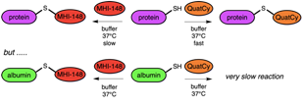

323. Productive Manipulation of Cyanine Dye π-Networks , S. M. Usama, K. Burgess, Angew. Chem. Int., 2019, 28, 8974–8976. (DOI: 10.1002/anie.201902956)
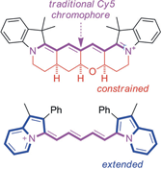

322. Correlations between secondary structure- and protein-protein interface-mimicry, J. . Taechalertpaisarn, R.-L. Lyu, M. Arancillo, C.-M. Lin, L. Perez, T. Ioerger, K. Burgess, Org. Bio. Chem., 2019, 17, 3267-3274. (DOI: 10.1039/c9ob00204a) PMID: 30847453
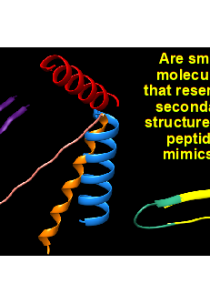

321. A Near-Infrared fluorescence chemosensor based on isothiocyanate-aza-BODIPY for cyanide detection at the parts per billion level: Applications in buffer media and living cell imaging, P. Piyanuch, J. Sirirak, A. Kamkaew, O. Weeranantanapa, V. Promarak, K. Burgess, N. Wanichacheva, ChemPlusChem, 2019, 84, 252-259. (DOI: 10.1002/cplu.201800574)
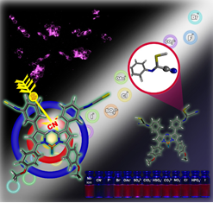

320. Design Criteria for Minimalist Mimics of Protein-protein Interface Segments, J. Taechalertpaisarn, R.-L. Lyu, M. Arancillo, C.-M. Lin, Z. Jiang, L. Perez, T. Ioerger, K. Burgess, Org. Bio. Chem., 2019, 17, 908-915. (DOI: 10.1039/C8OB02901F) PMID: 30629068
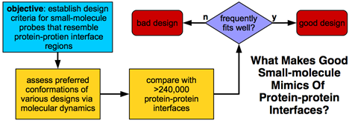

319. PROTACs Suppression of CDK4/6, Crucial Kinases for Cell Cycle Regulation in Cancer, B. Zhao, K. Burgess, Chem. Comm., 2019, 55, 2704-2707. (DOI: 10.1039/c9cc00163h) PMID: 30758029
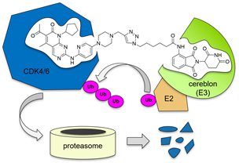

318. QuatCy: A Heptamethine Cyanine Modification With Improved Characteristics, S. Thavornpradit, S. M. Usama, J. P. Shrestha, G. K. Park, H. S. Choi, K. Burgess, Theranostics, 2019, 9, 2856-2857. (DOI: 10.7150/thno.33595)
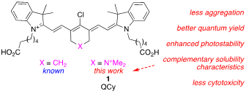

317. A Near-Ir Fluorescent Dasatinib Derivative That Localizes in Cancer Cells, S. M. Usama, B. Zhao, K. Burgess, Bioconjugate Chem., 2019, 30, 1175-1181. (DOI: 10.1021/acsbioconjchem.9b00118)
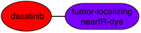

2018

316. Site Specific Labeling of Proteins with Near-IR dyes, C.-M. Lin, S. M. Usama, K. Burgess, Molecules, 2018, 23, 2900. (DOI: 10.3390/molecules23112900) PMID: 30405016
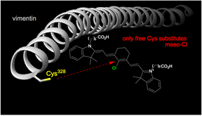

315. On the Mechanisms of Uptake of Tumor-seeking Cyanine Dyes, S. M. Usama, C.-M. Lin, K. Burgess, Bioconjugate Chem., 2018, 29, 3886-3895. (DOI: 10.1021/acs.bioconjchem.8b00708) PMID: 30354072
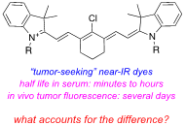

314. A Zwitterionic Near-infrared Dye Linked TrkC Targeting Agent for Imaging Metastatic Breast Cancer, Z. Yang, S. M. Usama, F. Li, K. Burgess, Z. Li, Med. Chem. Comm., 2018, 9, 1754-1760. (DOI: 10.1039/C8MD00190A) PMID: 30429980
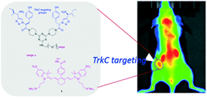

313. Targeted Maytansinoid Conjugate Improves Therapeutic Index for Metastatic Breast Cancer Cells, Z. Jiang, Z. Yang, F. Li, Z. Li, N. Fishkin, K. Burgess, Bioconjugate Chem., 2018, 29, 2920-2926. (DOI: 10.1021/acs.bioconjchem.8b00340) PMID: 30102524
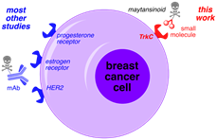

312. Optimized Heptamethine Cyanines for Photodynamic Therapy, S. Usama, S. Thavornpradit, K. Burgess, ACS Applied Bio Materials, 2018, 1, 1195-1205. (DOI: 10.1021/acsabm.8b00414)
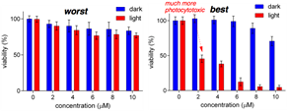

311. A Click-addressable Cassette for Photoaffinity Labeling, B. Zhao, K. Burgess, ACS Med. Chem. Letters, 2018, 9, 155-158. (DOI: 10.1021/acsmedchemlett.7b00516) PMID: 29456805
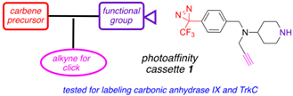

310. Small Molecule Inhibitors of the PCSK9-LDLR Interaction, J. Taechalertpaisarn, B. Zhao, X. Liang, K. Burgess, J. Am. Chem. Soc., 2018, 140, 3242-3248. (DOI: 10.1021/jacs.7b09360) PMID: 29378408
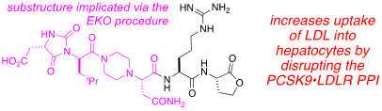

2017

309. Near-infrared aza-BODIPY fluorescent probe for selective Cu²⁺ detection and its potential in
living cell imaging, Y. Tachapermpon, S. Thavornpradit, A. Charoenpanich, J. Sirirak, K. Burgess, N. Wanichacheva, Dalton Transactions, 2017, 46, 16251-16256. (DOI: 10.1039/c7dt03481d) PMID: 29138771
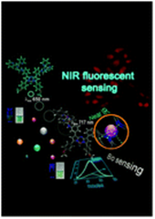

308. An Agent for Optical Imaging of TrkC-Expressing, Metastatic Breast Cancer, A. Kamkaew, F. Li, Z. Li, K. Burgess, Med. Chem. Comm., 2017, 8, 1946-1952. (DOI: 10.1039/c7md00328e) PMID: 30108715
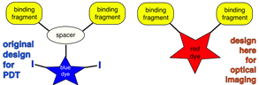

307. Interplay of Stereochemistry, Conformational Rigidity, and Ease of Synthesis for 13-Membered Cyclic Peptidomimetics Containing APC Residues, D. Xin, A. Jeffries, K. Burgess, ACS Comb. Sci., 2017, 17, 414-421. (DOI: 10.1021/acscombsci.7b00041) PMID: 28561582
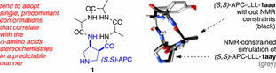

2016

307. Tropomyosin Receptor Kinase C Targeted Delivery of a Peptidomimetic Ligand-Photosensitizer Conjugate Induces Antitumor Immune Responses Folllowing Photodynamic Therapy, C. S. Kue, A. Kamkaew, S. H. Voon, L V. Kiew, L. Y. Chung, K. Burgess, H. B. Lee, Sci. Reports, 2016, 6, 37209-37225. (DOI: 10.1038/srep37209)

306. Novel Small Molecule Probes for Metastatic Melanoma, K. Burgess, A. Kamkaew, N. Fu, W. Cai, ACS Med. Chem. Lett., 2016, 8, 179-184. (DOI: 10.1021/acsmedchemlett.6b00368)
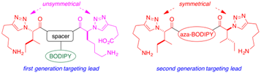

305. Heterogeneous Phase Transfer Catalysis in Solid Phase Syntheses of Anth-Cyclic Tetrapeptides, D. Xin, K.-Y. Wong, K. Burgess, J. Org. Chem., 2016, 81, 8077-8081. (DOI: 10.1021/acs.joc.6b01475)

304 Small Molecules for Active Targeting in Cancer, C. S. Kue, A. Kamkaew, K. Burgess, L. V. Kiew, L. Y. Chung, H. B. Lee, Med. Res. Rev., 2016, 36, 494-575. (DOI:10.1002/med.21387)

303. Anthranilic Acid-containing Cyclic Tetrapeptides: At the Crossroads of Conformational Rigidity and Synthetic Accessibility, D. Xin, K. Burgess, Org. Biomol. Chem., 2016, 14, 5049-5058. (DOI: 10.1039/C6OB00693K) PMID: 27173439
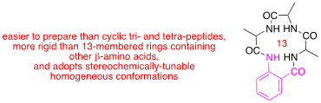

302. Chitosan-coated poly(lactic-co-glycolic acid)-diiodinated boron-dipyrromethene nanoparticles improve tumor selectivity and stealth properties in photodynamic cancer therapy , L. Chung, K. Burgess, J. Mat. Chem. B, 2015, 12, 1431-52. (DOI:10.116/jbn.201.2263) PMID: 26572434

2015

301. Aza-BODIPY Dyes With Enhanced Hydrophilicity, A. Kamkaew, K. Burgess, Chem. Comm., 2015, 51, 10664-7. (DOI: 10.1039/C5CC03649F) PMID: 26051677

300. Oligoethylene Glycol-substituted Aza-BODIPY Dyes as Red Emitting ER-Probes, S. Thavornpradit, T. Puangsamlee, A. Kamkaew, D. Xin, N. Wanichacheva, K. Burgess, Org. Biomol. Chem., 2015, 13, 8271-6. (DOI: 10.1029/c50b01104c) PMID: 26138325

299. Extended Piperidine-piperidinone Protein Interface Mimics, D. Xin, A. Raghuraman, K. Burgess, J. Org. Chem., 2015, 80, 4450-4458. (DOI 10.1021/acs.joc.5b00300) PMID: 25866317
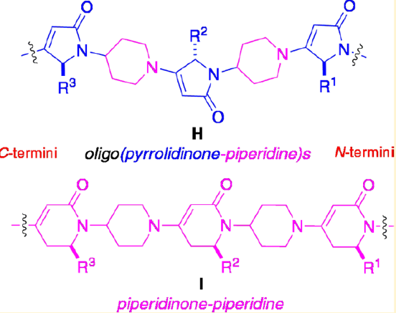

298. Protein-protein Interface Mimicry By An Oxazoline Piperidine-2,4-dione, X. Li, J. Taechalertpaisarn, D. Xin, K. Burgess, Org. Lett., 2015, 17, 632-635. (DOI 10.1021/ol5036547) PMID: 25625791
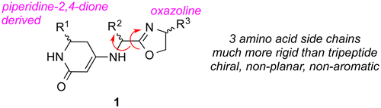

297. Targeted PDT Agent Eradicates TrkC Expressing Tumors Via Photodynamic Therapy (PDT), C. S. Kue, A. Kamkaew, H. B. Lee, L. Y. Chung, L. V. Kiew, K. Burgess, Mol. Pharmaceutics, 2015, 12, 212-22. (DOI: 1021/mp5005564) PMID: 25487316
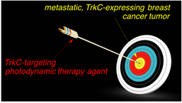

2014

296. In Vivo Studies of Nanostructure-Based Photosensitizers for Photodynamic Cancer Therapy, S. H. Voon, L. V. Kiew, H. B. Lee, S. H. Lim, M. I. Noordin, A. Kamkaew, K. Burgess and L. Y. Chung, Small, 2014, 10, 4993-5013. (DOI: 10.1002/smll.201401416)

295. Small Molecule Probes that Perturb A Protein-protein Interface In Antithrombin, D. Xin, A. Holzenburg, K. Burgess, Chem. Sci., 2014, 5, 4914-4921. (DOI: 10.1039/c4sc01295j)
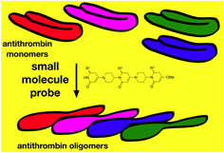
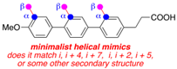

294. A Chemoselective Route to b-Enamino Esters and Thioesters, D. Xin, K. Burgess, Org. Lett., 2014, 16, 2108-2110. (DOI 10.1021/ol5005643)

293. A Multi-faced Secondary Structure Mimics Based on Piperidine-Piperidinones, D. Xin, L. M. Perez, T. R. Ioerger, K. Burgess, Angew. Chem., Int. Ed., 2014, 53, 3594-3498. (DOI: 10.1002/anie.201400927) PMC4019009
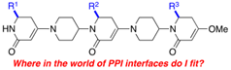

292. Metathesis for Catalyst Design: Metacatalysis, S. Khumsubdee, K. Burgess, Tetrahedron, 2014, 70, 1326-35. (DOI: http://dx.doi.org/10.1016/j.tet.2013.12.040)

291. Rosamines Targeting the Cancer Oxidative Phosphorylation Pathway, S. H. Lim, L. Wu, V. Kiew, L. Y. Chung, K. Burgess, H. B. Lee, PLOS One, 2014, 9, e82934. (DOI: 10.1371/journal.pone.0082934)

2013

290. Homo-Roche Ester Derivatives By Asymmetric Hydrogenation and Organocatalysis, S. Khumsubdee, H. Zhou, K. Burgess, J. Org. Chem., 2013, 78, 11948-55. (DOI 10.1021/jo401996m) PMCID 24219839

289. Double-targeting Using a TrkC-Ligand Conjugated to BODIPY-based PDT Agent, A. Kamkaew, K. Burgess, J. Med. Chem., 2013, 56, 7608-14. (DOI 10.1021/jm40121421). NIHMSID527496

288. A Comparison Between Oxazoline-imidazolinylidene, -imidazoylidine, -benzimidazoylidine Hydrogenations Catalysts, S. Khumsubdee, Y. Fan, K. Burgess, J. Org. Chem., 2013, 78, 9969-74. (DOI 10.1021/jo40137831) NIHMSID 525982

287. Expanding the Scope of Oligo-pyrrolinone-pyrrolidines as Protein-protein Interface Mimics, A. Raghuraman, D. Xin, L. M. Perez, K. Burgess, J. Org. Chem., 2013, 78, 4823-4833, (DOI: 10.1021/jo400323K) NIHMSID477321
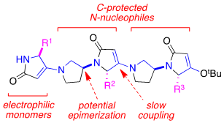

286. Evaluating Minimalist Mimics by Exploring Key Orientations on Secondary Structures (EKOS), D. Xin, E. Ko, L. M. Perez, T. R. Ioerger, K. Burgess, Org. Biomol. Chem. 2013, 11,7789-801. (DOI:10.1039/C3OB41848K) PMCID 24121516
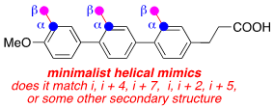

285. Comparison of Asymmetric Hydrogenations of Unsaturated-Carboxylic Acids and-Esters, S, Khumsubdee, K. Burgess, ACS Catalysis, 2013, 3, 237-249. (DOI: 10.21/cs3007389) NIHMSID438554

284. Highly Stereoselective Syntheses of all 1,2,3-Me, OH, Me Triads via Asymmetric Hydrogenation Reactions, Y. Zhu and K. Burgess, Adv. Synth. Cat., 2013, 355, 107-115. (DOI 10.1002/adsc.201200709) NIHMSID 431835

283. Exploring Key Orientations at Protein-Protein Interfaces with Small Molecule Probes, E. Ko, A. Raghuraman, L. M. Perez, T. R. Ioerger, K. Burgess, J. Am. Chem. Soc., 2013, 135, 167-173. (DOI 10.1021/ja3067258) NIHMSID 431835. PMCID: PMC3551583
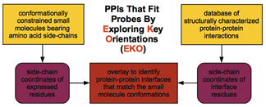

2012

282. Small Molecule Ligands for Active Targeting of TrkC-expressing Tumor Cells, E. Ko, A. Kamkaew, K. Burgess, ACS Med. Chem. Lett., 2012, 3, 1008-1012. (DOI: http://dx.doi.org/10.1021/ml300227d) NIHMS 413985

281. BODIPY Dyes in Photodynamic Therapy, A. Kamkaew, S. H. Lim, H. B. Lee, L. V. Kiew, L. Y. Chung, K. Burgess, Chem. Soc. Rev., 2012, 42, 77-88. (DOI: http://dx.doi.org/10.1039/C2CS35216H) PMCID: PMC3514588

280. Omegatides: Constrained Analogs of Peptide Primary Sequence, D. Fedoseyenko, A. Raghuraman, E. Ko, K. Burgess, Org. Biomol. Chem., 2012, 10, 921-4. (DOI: http://dx.doi.org/10.1039/C2OB06692K) PMID22179815

279. Iridium Catalyzed Enantioselective Hydrogenation of α-Alkoxy and β-Alkoxy Vinyl Ethers, Y. Zhu and K. Burgess, RSC Adv., 2012, 2, 4728-35. (DOI: 10.1039/c2ra01350a) NIHMSID 431835

278. Filling Gaps in Asymmetric Hydrogenation Methods for Acyclic Stereocontrol: Application to Chirons for Polyketide-derived Natural Products, Y. Zhu and K. Burgess, Acct. Chem. Res., 2012, 45, 1623-36. (DOI: 10.1021/ar200145q) PMID23035731

2011

277. (η⁴-1,5-Cyclooctadiene)(1-[(4S)-(2-(1-adamantyl)-4-5-dihydrooxazolyl)-ethyl]-3-(2,6-diisopropylphenyl)imidazolin-2-ylidene)iridium(I) Tetrakis(3,5-bis(tribluoromethyl)phenyl)borate, Y. Zhu, K. Burgess, EROS USGS, 2011. (DOI: 10.1002/047084289X.rn01336)

276. Continuous Flow Biocatalytic Resolutions of Methyl Sulfinylacetates, Z. Liu, K. Burgess, Tetrahedron Lett., 2011, 52, 6325-27. (DOI: 10.1016/j.tetlet.2011.09.024) NIHMSID 40135

275. Asymmetric Syntheses of α-Methyl γ-amino Acid Derivatives, Y. Zhu, S. Khumsubdee, A. Schaefer, K. Burgess, J. Org. Chem., 2011, 76, 7449-57. (DOI: 10.121/jo20125c)

274. Cationic Polyfluorenes for Intracellular Delivery of Proteins, A. Kamkaew, R. Barhoumi, R. C. Burghardt, K. Burgess, Org. Biomol. Chem., 2011, 9, 6513-8. (DOI: 10.1039/c1ob05874f) PMC3433840

273. Highly Efficient and Photostable Photonic Materials from Diiodinated BODIPY Laser Dyes, M. E. Pérez-Ojeda, C. Thivierge, V. Martin, A. Costela, K. Burgess and In. García-Moreno, Opt. Mat. Exp., 2011, 1, 243-51. (DOI: 10.1364/OME.1.000243)

272. Pyrrolinone-pyrrolidine Oligomers as Universal Peptidomimetics, A. Raghuraman, E. Ko, K. Burgess, J. Am. Chem. Soc., 2011, 133, 12350-12351. (DOI: 10.1021/ja2033734) PMC3154983
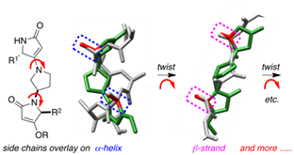

271. Minimalist and Universal Peptidomimetics, E. Ko, J. Liu, K. Burgess, Chem. Soc. Rev., 2011, 40, 4411-4421. (DOI: 10.1039/c0cs00218f) NIHMSID 40135

270. Brilliant BODIPY-fluorene Copolymers With Dispersed Absorption and Emission Maxima, C. Thivierge, A. Loudet, K. Burgess, Macromolecules, 2011, 44, 4012-4015. (DOI: 10.1021/ma200174w) PMC3145357

269. Pyrrole-based Scaffolds for Turn Mimics, E. Ko, K. Burgess, Org. Lett., 2011, 13, 980-3. (DOI: 10.1021/ol103022m) PMC3077957

268. Energy Transfer Cassettes in Silica Nanoparticles Target Intracellular Organelles, J. Jose, A. Loudet, Y. Ueno, L. Wu, H.-Y. Chen, D. H. Son, R. Barhoumi, R. Burghardt, K. Burgess, Org. Biomol. Chem., 2011, 9, 3871-77. (DOI: 10.1039/c0ob00967a) PMC21455504

267. Universal Peptidomimetics, E. Ko, J. Liu, L.M. Perez, G. Lu, A. Schaefer, K. Burgess, J. Am. Chem. Soc., 2011, 133, 462-77. (DOI: 10.1021/ja1071916) PMC3139828

266. Fluorescent Proton Sensors Based on Energy Transfer, C. Thivierge, J. Han, R. M. Jenkins, K. Burgess, J. Org. Chem., 2011, 76, 5219-28. (DOI: 10.1021/jo2005654) PMC3130547

265. Organelle-selective Energy Transfer: A Fluorescent Indicator of Intracellular Environment, A. Loudet, Y. Ueno, L. Wu, J. Jose, R. Barhoumi, K. Burgess, Bioorg. Med. Chem. Lett., 2011, 21, 1849-51. (DOI: 10.1016/j.bmcl.2011.01.040) PMC3061397

264. Encapsulated Energy Transfer Cassettes With Extremely Well Resolved Fluorescent Outputs, Y. Ueno, J. Jose, A. Loudet, C. Perez-Bolivar, P. Anzenbacher, K. Burgess, J. Am. Chem. Soc., 2011, 133, 51-5. (DOI: 10.1021/ja107193j) PMC3016467

2010

263. BODIPY® Dyes and Their Derivatives: Syntheses and Spectroscopic Properties, in “Handbook of Porphyrin Science: With Applications to Chemistry, Physics, Materials Science, Engineering, Biology and Medicine”, A. Loudet, K. Burgess; Ed. K. Kadish, K. Smith, R. Guilard, World Scientific, 2011, 203.

262. An Asymmetric Hydrogenation Route To (-)-Spongidepsin, Y. Zhu, A. Loudet, K. Burgess, Org. Lett., 2010, 12, 4392-5. (Highlighted in Synfacts 2011, 1, 0008). PMID 20822172

261. Intracellular Imaging of Organelles with New Water-soluble Benzaphenoxazine Dyes, J. Jose, A. Loudet, Y. Ueno, R. Barhoumi, R.C. Burghardt, K. Burgess, Org. Biomol. Chem., 2010, 8, 2052-9. PMID 20401381

260. A Combinatorial Approach for Targeted Delivery using Small Molecules and Reversible Masking to Bypass Non-Specific Uptake In Vivo, Q. Shi, A. Nguyen, Y. Angell, D. Deng, C.-R. Na, K. Burgess, D. Roberts, F. C. Brunicardi, N. Templeton, Gene Ther., 2010, 17, 1085-97. PMC2923228

259. In Vitro and In Vivo Photocytotoxicity of Boron Dipyrromethene Derivatives for Photodynamic Therapy, S. H. Lim, C. Thivierge, P. Nowak-Sliwinska, J. Han, H. Van den Bergh, G. Wagnieres, K. Burgess, H. B. Lee, J. Med. Chem., 2010, 53, 2865-74. PMID 20199028

258. Carbene-metal-hydrides Can Be Much Less Acidic Than Phosphine-metal-hydrides: Significance in Hydrogenations, Y. Zhu, Y. Fan, K. Burgess, J. Am. Chem. Soc., 2010, 132, 6249-53. PMID 20377250

257. Fluorescent Indicators for Intracellular pH, J. Han, K. Burgess, Chem. Rev., 2010, 110, 2709-28. PMID 20401381

256. A Monovalent Agonist of TrkA Tyrosine Kinase Receptors Can Be Converted into a Bivalent Antagonist, F. Brahimi, J. Liu, A. Malakhov, S. Chowdhury, E. Purisima, L. Ivanisevic, A. Caron, K. Burgess, H. Saragovi, Biochim. Biophys. Acta, 2010, 1800, 1018-26. PMC2943489

255. Bivalent Diketopiperazine-based TrkC Antagonists, J. Liu, F. Brahimi, H. U. Saragovi, K. Burgess, J. Med. Chem., 2010, 53, 5044-8. PMC2907676

254. In Glaucoma the Up-regulated Truncated TrkC.T1 Receptor Isoform in Glia Causes Increased
TNF-α Production, leading to retinal ganglion cell death, Y. Bai, Z. Shi, Y. Zhuo, J. Liu, A. Malakhov, E. Ko, K. Burgess, H. Schaefer, P. Esteban, L. Tessarollo, and H. Saragovi, Invest. Ophthal. Vis. Sci., 2010, 51, 6639-51. PMID 20574020

2009

253. A Peptidomimetic of NT-3 acts as a TrkC antagonist, F. Brahimi, A. Malakhov, H. B. Lee, M. Pattawarapan, L. Ivanisevic, K. Burgess, H. U. Saragovi, Peptides, 2009, 1833-9. PMC2755609

252. Energy transfer dyads based on Nile Red, J. Jose, Y. Ueno, J.C. Castro, L. Li, K. Burgess, Tetrahedron Lett., 2009, 50, 6442-5. PMC2770174

251. Synthesis of Vicinal Dimethyl Chirons by Asymmetric Hydrogenation of Trisubstituted Alkenes, J. Zhao, K. Burgess, J. Am. Chem. Soc., 2009, 131, 13236-7. PMID 19719102

250. New Cytotoxic Rosamine Derivatives Selectively Accumulate in the Mitochondria of Cancer Cells, S.A. Lim, L. Wu, K. Burgess, H.B. Lee, Anti-Cancer Drugs, 2009, 20, 461-8.

249. Fluorescent Cassettes for Monitoring Three-component Interactions In Vitro and Ex Vivo, L. Wu, A. Loudet, R. Barhoumi, R.C. Burghardt, K. Burgess, J. Am. Chem. Soc., 2009, 131, 9156-7. PMC2717018

248. Bivalent Peptidomimetic Ligands of TrkC are Biased Agonists, Selectively Induce Neuritogenesis, or Potentiate Neurotrophin-3 Trophic Signals, D. Chen, F. Brahimi, Y. Angell, Y.-C. Li, J. Moscowitz, H. U. Saragovi, K. Burgess, ACS Chem. Biol., 2009, 4, 769-81. PMC2756187

247. Synthesis of Regiosomerically Pure 5-Functionalized 2’, 7’–Dichlorofluoresceins, K. Burgess, J. C. Castro, A. Malakhov, Synthesis, 2009, 7, 1224-6.

246. Aldol-type Chirons From Asymmetric Hydrogenations of Trisubstituted Alkenes, K. Burgess, J. Zhao, Org. Lett., 2009, 11, 2053-6. PMID 19368378

245. Photophysics and Stability of Cyano-Substituted Boradiazaindacene Dyes, K. Cieslik-Boczula, K. Burgess, L. Li, B. Nguyen, L. Pandey, W. M. De Borggraee, M. Van der Auweraer, N. Boens, Photochem. Photobiol., 2009, 8, 1006-15.

244. A Ratiometric pH Reporter For Imaging Protein-dye Conjugates in Living Cells, J. Han, A. Loudet, R. Barhoumi, R. Burghardt, K. Burgess, J. Am. Chem. Soc., 2009, 131, 1642-3. PMC2720788

243. Water-soluble Nile Blue Derivatives: Syntheses and Photophysical Properties, J. Jose, Y. Ueno,
K. Burgess, Chem.—Eur. J., 2009, 15, 418-23.

242. 3- and 5-Functionalized BODIPYs via The Liebeskind-Srogl Reaction, J. Han, O. Gonzalez, A. Aguilar-Aguilar, E. Pena-Cabrera K. Burgess, Org. Biomol. Chem., 2009, 7, 34-6.

2008

241. B,O-Chelated Azadipyrromethenes as Near-IR Probes, K. Burgess, A. Loudet, R. Bandichhor, A. Palma, S. McDonnell, M. Hall, Org. Lett., 2008, 10, 4771-4. (Highlighted in Synfacts 2009, 2, 150). PMC2631357

240. A New Synthesis of Symmetric Boraindacene (BODIPY) Dyes, L. Wu, K. Burgess, Chem. Commun., 2008, 40, 4933-5.

239. Non-Covalent Delivery of Proteins into Mammalian Cells, A. Loudet, J. Han, R. Barhoumi, J-P. Pellois, R. C. Burghardt, K. Burgess, Org. Biomol. Chem., 2008, 6, 4516-22. PMID 19039359

238. Synthesis and Spectroscopic Properties of Rosamines with Cyclic Amine Substituents, L. Wu, K. Burgess, J. Org. Chem., 2008, 73, 8711-8.

237. Asymmetric Hydrogenation Approaches to Valuable, Acyclic 1,3-Hydroxymethyl Chirons, K. Burgess, Y. Zhu, J. Am. Chem. Soc., 2008, 130, 8894-5. (Highlighted in Synfacts 2008, 11, 1176.) PMID 18563899

236. Fluorescent Amino-and Thiopyronin Dyes, L. Wu, K. Burgess, Org. Lett., 2008, 10, 1779-82. (Highlighted in Synfacts, 2008, 7, 699).

235. Syntheses of Highly Fluorescent GFP-chromophore Analogs, L. Wu, K. Burgess, J. Am. Chem. Soc., 2008, 130, 4089-96.

234. Functionalization of the 4,4-Difluoro-4-bora-3a,4a-diaza-s-indacene (BODIPY) Core, L. Li, B. Nguyen, K. Burgess, Biorg. Med. Chem. Lett., 2008, 18, 3112-6. PMC2430868

233. Syntheses and Spectral Properties of Functionalized, Water-soluble BODIPY Derivatives, L. Li, J. Han, B. Nguyen, K. Burgess, J. Org. Chem., 2008, 73, 1963-70.

232. Iridium-Catalyzed Asymmetric Hydrogenation of Vinyl Ether, Y. Zhu, K. Burgess, Adv. Synth. Catal., 2008, 350, 979-83. (Highlighted in Synfacts 2008, 7, 733.)

231. Lipid Diffusion from Single Molecules of a Labeled Protein Undergoing Dynamic Association with Giant Unilamellar Vesicles and Supported Bilayers, A. Sharonov, R. Bandichhor, K. Burgess, A. Petrescu, F. Schroeder, A. Kier, R. Hochstrasser, Langmuir, 2008, 24, 844-50.

230. Functionalized BF₂ Chelated Azadipyrromethene Dyes, A. Loudet, R. Bandichhor, L. Wu, K. Burgess, Tetrahedron, 2008, 64, 3642-54. PMC2390871

229. A Combinatorial Method for Solution-phase Synthesis of Labeled Bivalent β-Turn Mimics, Y.
Angell, D. Chen, F. Brahimi, H. U. Saragovi, K. Burgess, J. Am. Chem. Soc., 2008, 130, 556-65.
PMID 18088119

2007

228. BODIPY® Dyes and Their Derivatives: Syntheses and Spectroscopic Properties, A. Loudet, K. Burgess, Chem. Rev., 2007, 107, 4891-932.

227. Peptidomimetics via Copper-catalyzed Azide-alkyne Cycloadditions, Y. Angell, K. Burgess, Chem. Soc. Rev., 2007, 36, 1674-89. PMID 17721589

226. Spectral Dispersion, and Water Solubilization, of BODIPY Dyes via Palladium Catalyzed C-H Functionalization, C. Thivierge, R. Bandichhor, K. Burgess, Org. Lett., 2007, 9, 2135-8.

225. Synthesis of (S,R,R,S,R,S)-4,6,8,10,16,18-Hexamethyldocosane from Antitrogus parvulus via Diastereoselective Hydrogenations, J. Zhou, K. Burgess Org. Lett., 2007, 9, 1391-3. PMID 17338543

224. Asymmetric Hydrogenation Routes to Deoxypolyketide Chirons, J. Zhou, J. W. Ogle, Y. Fan, V. Banphavichit, Y. Zhu, K. Burgess, Chem.—Eur. J., 2007, 13, 7162-70. PMID 17582818

223. New Optically Active N-Heterocyclic Carbene Complexes for Hydrogenation: A Tale With an Atropisomeric Twist, D. Chen, V. Banphavichit, J. Reibenspies, K. Burgess, Organometallics, 2007, 26, 855-9.

222. Base Dependence in Copper-Catalyzed Huisgen Reactions: Efficient Formation of Bistriazoles, Y. Angell, K. Burgess, Angew. Chem., Int. Ed. Engl., 2007, 46 3649-51. PMID 17410632

221. Chemiluminescent Energy Transfer Cassettes Based on Fluorescein and Nile Red, J. Han, J. Jose, E. Mei, K. Burgess, Angew. Chem., Int. Ed. Engl., 2007, 46, 1684-7.

220. α,ω Functionalized 2,4-Dimethylpentane Dyads and 2,4,6-Trimethylheptane Triads via Asymmetric Hydrogenation, J. Zhou, K. Burgess, Angew. Chem., Int. Ed. Engl., 2007, 46, 1129-31. PMID 17200966

2006

219. 4,4-Difluoro-1,3,5,7-tetramethyl-4-bora-3a,4a-diaza-s-indacene, R. Bandichhor, C. Thivierge, N. S. P. Bhuvanesh, K. Burgess, Acta Crystallogr., Sect. E, 2006, 64, 4310-11.

218. Benzophenoxazine-based Fluorescent Dyes for Labeling Biomolecules, J. Jose and K. Burgess, Tetrahedron, 2006, 62, 11021-37.

217. Syntheses and Properties of Water-soluble Nile Red Derivatives, J. Jose, K. Burgess, J. Org. Chem., 2006, 71, 7835-9.

216. Synthesis of a New Water-Soluble Rhodamine Derivative and Application to Protein Labeling and Intracellular Imaging, R. Bandichhor, A. D. Petrescu, A. Vespa, A. B. Kier, F. Schroeder, K. Burgess, Bioconjugate Chem., 2006, 17, 1219-25.

215. Water-soluble Through-bond Energy Transfer Cassettes in Intracellular Imaging, R. Bandichhor, A. D. Petrescu, A. Vespa, A. B. Kier, F. Schroeder, K. Burgess, J. Am. Chem. Soc., 2006, 128, 10688-9.

214. Ir-Catalyzed C-H Activation of Porphyrins and Corroles, R. Bandichhor, C. Thivierge, K. Burgess, ChemTracts, 2006, 19, 11-16.

213. A Diversity Oriented Synthesis of 3’-O-Modified Nucleoside Triphosphates for DNA “Sequencing by Synthesis”, G. Lu, K. Burgess, Bioorg. Med. Chem. Lett., 2006, 16, 3902-5.

212. Syntheses, Photophysical Properties, and Applications of Through-Bond Energy-Transfer Cassettes for Biotechnology, G.-S. Jiao, L. H. Thoresen, T. G. Kim, W. C. Haaland, F. Gao, M. R. Topp, R. M. Hochstrasser, M. L. Metzker, K. Burgess, Chem. Eur. J., 2006, 12, 7616-26.

211. Cyclic-Semipeptoids: Peptoid-Organic Hybrid Macrocycles, E. Nnanabu, K. Burgess, Org. Lett., 2006, 8, 1259-62. PMID 16562866

210. An Iterative Route to Functionalized Ethylene Glycol-based Linkers, G. Lu, S. Lam, K. Burgess, Chem. Commun., 2006, 1652-4.

209, Femtosecond-domain Dynamical Studies of Energy-Transfer Cassettes, T. G. Kim, J. C. Castro, A. Loudet, J. G.-S Jiao, R. M. Hochstrasser, K. Burgess, M. R. Topp, Proceedings of the Femtochemistry VII Conference, Elsevier, Amsterdam, 2006, 128-131.

208. Heterovalent Selectivity and the Combinatorial Advantage, S. J. Reyes, K. Burgess, Chem. Soc. Rev., 2006, 35, 416-23. PMID 16636725

207. On Formation of Thiohydantoins From Amino Acids Under Acylation Conditions, S. J. Reyes, K. Burgess, J. Org. Chem., 2006, 71, 2507-9.

206. Correlations of Structure and Rates of Energy Transfer for Through-Bond Energy Transfer Cassettes, T. G. Kim, J. C. Castro, A. Loudet, J. G.-S. Jiao, R. M. Hochstrasser, K. Burgess, M. R. Topp, J. Phys. Chem., 2006, 110, 20-7.

2005

205. Ring Closure to β-Turn Mimics via Copper Catalyzed Azide/Alkyne Cycloadditions, Y. Li, K. Burgess, J. Org. Chem., 2005, 70, 9595-98. DOI: 10.1021/jo0516180, PMID 16268639

204. Mechanistic Insights into Iridium-Catalyzed Asymmetric Hydrogenations of Dienes, X. Cui, Y. Fan, M. B. Hall, K. Burgess, Chem.—Eur. J., 2005, 11, 6859-68. PMID 16163756

203. Catalytic Homogeneous Asymmetric Hydrogenations of Largely Unfunctionalized Alkenes, X. Cui, K. Burgess, Chem. Rev., 2005, 105, 3272-96. PMID 16159153

202. Stereoselective Hydrogenations of Aryl-substituted Dienes, X. Cui, J. Ogle, K. Burgess, Chem. Commun., 2005, 672-4. PMID 15672173

201. β-Turn Peptidomimetics Incorporating i + 1 – i + 3 Residues: Solid Phase Syntheses and Conformational Properties, S. J. Reyes, K. Burgess, Tetrahedron: Asymmetry, 2005, 16, 1061-9.

200. Selective Small Molecule Peptidomimetic Ligands of TrkC and of TrkA Receptors Afford Discrete or Complete Neurotrophic Activities, M. C. Zaccaro, H. B. Lee, M. Pattarawarapan, Z. Xia, A. Caron, K. Burgess, H. U. Saragovi, Chemistry & Biology, 2005, 12, 1015-28. PMID 16183026

2004

199. Electronic Effects Steer The Mechanism of Asymmetric Hydrogenations of Unfunctionalized Aryl-substituted Alkenes, Y. Fan, X. Cui, K. Burgess, M. B. Hall, J. Am. Chem. Soc., 2004, 126, 16688-9. PMID 15612683

198. Long-Lasting Rescue of Age-Associated Deficits in Cognition and the CNS Cholinergic Phenotype by a Partial Agonist Peptidomimetic Ligand of TrkA, M. A. Bruno, P. B. S. Clarke, A. Seltzer, R. Quirion, K. Burgess, A. C. Cuello, H. U. Saragovi, J. Neuroscience, 2004, 24, 8009-18. PMID 15371501

197. Preparation of 5- and 6-Carboxyfluorescein, Y. Ueno, G.-S. Jiao, K. Burgess, Synthesis, 2004, 15, 2591-3.

196. A Blue-to-red Energy-transfer Thymidine Analog That Functions In DNA, G.-S. Jiao, T. G. Kim, K. Burgess, Org. Lett., 2004, 6, 1701-4.

195. On the stability of furanopyrimidin-2-one bases in oligonucelotides, G.-S. Jiao, K. Burgess, Chem. Commun., 2004, 1304-5.

194. Solid Phase Syntheses of Monovalent and Bivalent Peptidomimetics of the Neurotrophins, K. Burgess in "Peptide Revolution: Genomics, Proteomics & Therapeutics” 18th American Peptide Symposium Proceedings, M. Chorev, T. K. Sawyer, Eds., 2004, 205-9.

193. Chiral Imidazolylidine Ligands for Asymmetric Catalysis in "New Methodologies in Asymmetric Catalysis", ACS Publications, S. Malhotra, Ed., 2004, 61-84.

192. Syntheses and Activities of New C¹⁰ β-Turn Peptidomimetics, H. B. Lee, M. C. Zaccaro, M. Pattarawarapan, S. Roy, H. U. Saragovi and K. Burgess, J. Org. Chem., 2004, 69, 701-13. DOI: 10.1021/jo034167x, PMID 14750794

2003

191. Molecular Basis of Neurotrophin-receptor Interactions, M. Pattarawarapan and K. Burgess, J. Med. Chem., 2003, 46, 5277-91.

190. Iridium-Mediated Asymmetric Hydrogenation of 2,3-Diphenylbutadiene: A Revealing Kinetic Study, X. Cui, K. Burgess, J. Am. Chem. Soc., 2003, 125, 14212-3. PMID 14624534

189. Fluorescent, Through-Bond Energy Transfer Cassettes for Labeling Multiple Biological Molecules in One Experiment, G.-S. Jiao, L. H. Thoresen, K. Burgess, J. Am. Chem. Soc., 2003, 125, 14668-9.

188. Microwave-assisted functionalization of bromo-fluorescein and bromorhodamine derivatives, J. W. Han, J. C. Castro, K. Burgess, Tetrahedron Lett., 2003, 44, 9359-62.

187. Microwave-Assisted Syntheses of Regioisomerically Pure Bromorhodamine Derivatives, G.-S. Jiao, J. C. Castro, L. H. Thoresen, K. Burgess, Org. Lett., 2003, 5, 3675-7.

186. Syntheses of Regioisomerically Pure 5- or 6- Halogenated Fluoresceins, G.-S. Jiao, J. W. Han, K. Burgess, J. Org. Chem., 2003, 68, 8264-7.

185. Selective Formation of Homo- and Heterobivalent Peptidomimetics, M. Pattarawarapan, S. Reyes, Z. Xia, M. C. Zaccaro, H. U. Saragovi, K. Burgess, J. Med. Chem., 2003, 46, 3565-7. PMID 12904060

184. Anthracene-BODIPY Cassettes: Syntheses and Energy Transfer, C.-W. Wan, A. Burghart, J. Chen, F. Bergstrom, L. B.-A. Johansson, M. F. Wolford, T. G. Kim, M. R. Topp, R. M. Hochstrasser and K. Burgess, Chem.—Eur. J., 2003, 9, 4430-41.

183. Oligonucleotides With Strongly Fluorescent Groups Conjugated To A Nucleobase: Syntheses, Melting Temperatures, and Conformation, G.-S. Jiao and K. Burgess, Bioorg. Med. Chem. Lett., 2003, 13, 2785-8.

182. Rigid, Conjugated, Fluoresceinated Thymidine Triphosphates: Syntheses and Polymerase Mediated Incorporation Into DNA Analogues, L. H. Thoresen, G.-S. Jiao, W. C. Haaland, M. L. Metzker, K. Burgess, Chem.—Eur. J., 2003, 9, 4603-10.

181. Syntheses of "Second Generation", 14-Membered Ring β-Turn Mimics, H. B. Lee, M. Pattarawarapan, S. Roy, K. Burgess, Chem. Commun., 2003, 1674-5. DOI: 10.1039/B304454H

180. Chiral N-Heterocyclic Carbene Complexes in Asymmetric Catalysis, M. C. Perry and K. Burgess, Tetrahedron: Asymmetry, 2003, 14, 951-61.

179. Syntheses and Spectrosopic Properties of Energy Transfer Systems Based on Squaraines, G.S. Jiao, A. Loudet, H. B. Lee, S. Kalinin, L. B.-Å. Johansson, K. Burgess, Tetrahedron, 2003, 59, 3109-16.

178. Metal-Catalyzed Epoxidations of Alkenes with Hydrogen Peroxide, B. S. Lane and K. Burgess, Chem. Rev., 2003, 103, 2457-72.

177. Optically Active Iridium Imidazol-2-ylidene-oxazoline Complexes: Preparation and Use in Asymmetric Hydrogenation of Arylalkenes, M. C. Perry, X. Cui, M. T. Powell, D.-R. Hou, J. H. Reibenspies and K. Burgess, J. Am. Chem. Soc., 2003, 125, 113-23. PMID 12515512

2002

176. Fluorinated and Iodinated Templates for Syntheses of β-Turn Peptidomimetics, L. Jiang and K. Burgess, Tetrahedron, 2002, 58, 8743-50.

175. A Modular Approach to trans-Chelating, N-Heterocyclic Carbene Ligand Complexes, M. C. Perry, X. Cui, K. Burgess, Tetrahedron: Asymmetry, 2002, 13, 1969-72.

174. Manganese Catalyzed Epoxidations of Alkenes in Bicarbonate Solutions, B. S. Lane, M. Vogt, V. J. DeRose, K. Burgess, J. Am. Chem. Soc., 2002, 124, 11946-54.

173. Total Syntheses of Vancomycin, L. H. Thoresen, K. Burgess in Organic Synthesis Highlights V, Schmalz and Wirth, Eds., Wiley-Vch, Weinheim, 2002, 297-306.

172. New Templates for Syntheses of Ring-fused, C¹⁰ β-Turn Peptidomimetics Leading To The First Reported Small Molecule Mimics of NT-3, M. Pattarawarapan, M. C. Zaccaro, U. H. Saragovi, K. Burgess, J. Med. Chem., 2002, 45, 4387-90. DOI: 10.1021/jm0255421

171. Oxidative Induction of β-Turn Conformations in Cyclic Peptidomimetics: Conformational Analyses as Indicators of Configuration, L. Jiang, K. Burgess, J. Am. Chem. Soc., 2002, 124, 9028-9. DOI: 10.1021/ja0171411

2001

170. Solid Phase Syntheses of β-Turn Analogues To Mimic or Disrupt Protein-Protein Interactions, K. Burgess, Acc. Chem. Res., 2001, 34, 826-35. DOI: 10.1021/ar9901523 PMID 11601967

169. Enantioselective Hydrogenations of Arylalkenes Mediated by Ir(JM-Phos) Complexes, D.-R. Hou, J. H. Reibenspies, T. A. Colacot, K. Burgess, Chem.—Eur. J., 2001, 7, 5391-400. PMID 11822439

168. Chiral Imidazolylidine Ligands for Asymmetric Hydrogenation of Aryl Alkenes, M. T. Powell, D.-R. Hou, M. C. Perry, X. Cui, K. Burgess, J. Am. Chem. Soc., 2001, 123, 8878-9. PMID 11535106

167. Facile Macrocyclizations to β-Turn Mimics with Diverse Structural, Physical, and Conformational Properties, C. Park and K. Burgess, J. Comb. Chem., 2001, 3, 257-66. DOI: 10.1021/cc010003n

166. Optically Active C³-Symmetric Triarylphosphines in Asymmetric Allylations, M. T. Powell, A. M. Porte, J. Reibenspies, K. Burgess, Tetrahedron, 2001, 57, 5027-38.

165. A Cheap, Catalytic, Scalable, and Environmentally Benign Method for Alkene Epoxidations, B. Lane, K. Burgess, J. Am. Chem. Soc., 2001, 123, 2933-4.

164. DiSSiMiL: Diverse Small Size Mini-Libraries Applied to Simple and Rapid Epitope Mapping of a monoclonal Antibody, K. Burgess, I. Han, A. Zhang, W.-H. Zheng, K. Shanmugam, M.S. Featherstone, H.U. Saragovi, J. Peptide Res., 2001, 57, 68-76.

163. Dimeric β-Turn Peptidomimetics as Ligands for the Neurotrophin Receptor TrkC, A. J. Zhang, S. Khare, D. S. Linthicum, K. Burgess, Bioorg. Med. Chem. Lett., 2001, 11, 207-10.

162. A Rigid Linker-Scaffold for Solid Phase Synthesis of Dimeric Pharmacophores, M. Pattarawarapan, J. Chen, M. Steffensen, K. Burgess, J. Comb. Chem., 2001, 3, 102-16.

161. New, Optically Active, Phosphine Oxazoline (JM-Phos) Ligands: Syntheses and Applications in Allylation Reactions, D.-R. Hou, J. Reibenspies and K. Burgess, J. Org. Chem., 2001, 66, 206-15.

2000

160. Energy Transfer Cassettes Based on BODIPY Dyes, A. Burghart, L. H. Thoresen, J. Chen, K. Burgess, F. Bergström and L. B.-A. Johansson, Chem. Commun., 2000, 2203-4.

159. A Linker-Scaffold to Present Dimers of Pharmacophores Prepared via Solid Phase Syntheses, M. Pattarawarapan and K. Burgess, Angew. Chem., Int. Ed. Engl., 2000, 39, 4299-301.

158. Preferred Secondary Structures as a Possible Driving Force for Macrocyclization, S. Reyes, M. Pattarawarapan, S. Roy, K. Burgess, Tetrahedron, 2000, 56, 9809-18.

157. Syntheses of Nucleoside Triphosphates, K. Burgess and D. Cook, Chem. Rev., 2000, 100, 2047-59.

156. Synthesis and Spectroscopic Properties of 2-Ketopyrrole-BF₂ Complexes: A New Class of Fluorescent Dye, J. Chen., A. Burghart, C.-W. Wan, L. Thai, C. Ortiz, J. Reibenspies, K. Burgess, Tetrahedron Lett., 2000, 41, 2303-7.

154. 4,4-Difluoro-4-bora-3a,4a-diaza-s-indacene (BODIPY®) Dyes Modified for Extended Conjugation and Restricted Bond Rotations, J. Chen, A. Burghart, A. Derecskei-Kovacs, K. Burgess, J. Org. Chem., 2000, 65, 2900-6.

153. Solution- and Solid-Phase Syntheses of Substituted Guanidinocarboxylic Acids, J. Chen, M. Pattarawarapan, A. J. Zhang, K. Burgess, J. Comb. Chem., 2000, 2, 276-81.

152. A Designed Peptidomimetic Agonistic Ligand of TrkA NGF Receptors, S. Maliartchouk, Y. Feng, L. Ivanisevic, T. Debeir, A. C. Cuello, K. Burgess, H. U. Saragovi, J. Mol. Pharm., 2000, 57, 385-91. PMID 10648649

151. Resin Effects in Solid Phase S_{N}Ar and S_{N}2 Macrocyclizations, Y. Feng and K. Burgess, Biotech. Bioeng. Comb. Chem., 2000, 71, 3-8.

150. New Chemistry of BODIPY Dyes, and BODIPY Dye Cassettes Featuring Through-Bond Energy Transfer, K. Burgess, A. Burghart, J. Chen, C.-W. Wan, SPIE Conference Proceedings: Advances in Nucleic Acid and Protein Analyses, Manipulation, and Sequencing, San Jose, California, January, 2000, 95-105.

149. Solid Phase Syntheses of Guanidines, K. Burgess, J. Chen in Solid-Phase Organic Synthesis, K. Burgess, Ed., Wiley & Sons, New York, 2000, 1-23.

1999

148. Through-space ¹³C - ¹⁹F Coupling Can Reveal Conformations of Modified BODIPY Dyes, J. Chen, J. Reibenspies, A. Derecskei-Kovacs, K. Burgess, Chem. Commun., 1999, 2501-2.

147. Stereochemical Implications on Diversity in β-Turn Peptidomimetic Libraries, Y. Feng, M. Pattarawarapan, Z. Wang, K. Burgess, J. Org. Chem., 1999, 64, 9175-7.

146. JM-PHOS Ligands: Second-generation Phosphine Oxazolines for Asymmetric Catalysis, D.-R. Hou, K. Burgess, Org. Lett., 1999, 1, 1745-7. PMID 11429902

145. Small Molecule and Protein-based Neurotrophic Ligands: Agonists and Antagonists as Therapeutic Agents", H. U. Saragovi, K. Burgess, Exp. Opin. Ther. Patents, 1999, 9, 737-51.

144. A New Solid-Phase Linker for Suzuki Coupling with Concomitant Macrocyclization: Synthesis of β-Turn Mimics, W. Li and K. Burgess, Tetrahedron Lett., 1999, 40, 6527-30.

143. Synthesis and Spectroscopic Properties of a New Fluorescent Dye, H. Kim, A. Burghart, M. B. Welch, J. Reibenspies, K. Burgess, Chem. Commun., 1999, 1889-90.

142. Solid Phase S_{N}Ar Macrocyclizations To Give Turn-extended-turn Peptidomimetics, Y. Feng, K. Burgess, Chem.—Eur. J., 1999, 5, 3261-72.

141. Conformations of Peptidomimetics Formed by S_{N}Ar Macrocyclizations: 13 to 16-Membered Ring Systems, Y. Feng. Z. Wang, S. Jin, K. Burgess, Chem.—Eur. J., 1999, 5, 3273-8.

140. 3,5-Diaryl-4,4-difluoro-4-bora-3a,4a-diaza-s-indacene (BODIPY®) Dyes: Synthesis, Spectroscopic, Electrochemical Structural Properties, A. Burghart, H. Kim, M. B. Welch, L. H. Thoresen, J. Reibenspies, K. Burgess, F. Bergström, L. B.-A. Johansson, J. Org. Chem., 1999, 64, 7813-9.

139. Solid-Phase S_{N}2 Macrocyclization Reactions to Form β-Turn Mimics, Y. Feng, M. Pattarawarapan, Z. Wang, K. Burgess, Org. Lett., 1999, 1, 121-4. DOI: 10.1021/ol990597r

138. An Allylic/Acyclic Adenosine Nucleoside Triphosphate for Termination of DNA Synthesis by DNA-Template Dependent Polymerases, C. I. Martinez, L. H. Thoresen, R. A. Gibbs, K. Burgess, Nucleic Acids Res., 1999, 27, 1271-4.

137. Syntheses of Nucleosides Designed for Combinatorial DNA Sequencing, M. B. Welch, C. I. Martinez, A. J. Zhang, S. Jin, R. Gibbs, K. Burgess, Chem.—Eur. J., 1999, 5, 951-60.

136. Cyclopropane Amino Acids that Mimic Two c¹- Conformations of Phenylalanine, D. Moye-Sherman, S. Jin, S. Li, M. B. Welch, J. Reibenspies, K. Burgess, Chem.—Eur. J., 1999, 5, 2730-9.

135. Total Synthesis of Vancomycin, A. J. Zhang, K. Burgess, Angew. Chem., Int. Ed. Engl., 1999, 38, 634-6.

134. Synthesis of Fluorescent, Photolabile 3’-O-Protected Nucleoside Triphosphates for the Base Addition Sequencing Scheme, M. B. Welch, K. Burgess, Nucleosides Nucleotides, 1999, 18, 197-201.

133. Book Review of "Combinatorial Chemistry and Molecular Diversity in Drug Discovery", M. Gordon and J. F. Kerwin, eds., Wiley: New York, 1998, ChemTracts, 1999, 12, 302.

1998

132. Photochemistry of Os₃(CO)₁₂ with AuPPh₃Cl: Synthesis and Structural Characterization of (m-AuPPh₃)(m-Cl)Os₃(CO)₁₀, C. H. Hay, N. E. Leadbeater, J. Lewis, P. R. Raithby, K. Burgess, New. J. Chem., 1998, 787-8.

131. 2,3-Methanoamino Acid Analogs of Arg Stabilize Secondary Structures of a 13-Amino Acid Peptide in Aqueous Solution, D.-Y. Lim, D. Moye-Sherman, I. Ham, S. Jin, J. M. Scholtz, K. Burgess, Chem. Commun., 1998, 2375-6.

130. Elimination of Residual Natural Nucleotides from 3’O-Modified-dNTP Syntheses by Enzymatic Mop-up, M. L. Metzker, R. Raghavachari, K. Burgess, R. A. Gibbs, BioTechniques, 1998, 25, 814-7.

129. Asymmetric Synthesis of 3-Phenyl-2,3-methanophenylalanine Developed by Panning Catalysts in a Library Format, D. Moye-Sherman, M. B. Welch, J. Reibenspies, K. Burgess, Chem. Commun., 1998, 2377-8.

128. S_{N}Ar Cyclization to Form Cyclic Peptidomimetics of β-Turns, Y. Feng, Z. Wang, S. Jin, K. Burgess, J. Am. Chem. Soc., 1998, 120, 10768-9.

127. On the Efficacy of Propeller-shaped, C₃-Symmetric Triarylphosphines in Asymmetric Catalysis. 1., M. T. Powell, A. M. Porte, K. Burgess, Chem. Commun., 1998, 2161-2.

126. A Method for Removal of N-BOC Protecting Groups from Substrates on TFA-sensitive Resins, A. J. Zhang, D. H. Russell, J. Zhu, K. Burgess, Tetrahedron Lett., 1998, 39, 7439-42.

125. Synthesis of 3,5-Diaryl-4,4-difluoro-4-bora-3a,4a-diaza-s-indacene (BODIPY) Dyes, L. H. Thoresen, H. Kim, M. B. Welch, A. Burghart, K. Burgess, Synlett, 1998, 1276-8.

124. Design and Optimization of New Phosphine Oxazoline Ligands via High Throughput Catalyst Screening, A. M. Porte, J. Reibenspies, K. Burgess, J. Am. Chem. Soc., 1998, 120, 9180-7.

123. Conformational Preferences of RNase A C-Peptide Derivatives Containing a Highly Constrained Analog of Phenylalanine, D. Moye-Sherman, S. Jin, I. Ham, D.Y. Lim, J. M. Scholtz, K. Burgess, J. Am. Chem. Soc., 1998, 120, 9435-43.

122. Application of Novel Phosphine Oxazoline Ligands in Asymmetric Allylations of 4-Acyloxy-2-pentene Derivatives, K. Burgess, A. M. Porte, Tetrahedron: Asymmetry, 1998, 9, 2465-9.

121. New and Efficient Synthesis of an Amino Acid for Preparing Phosphine-Functionalized Peptidomimetics, A. M. Porte, W. A. van der Donk, K. Burgess, J. Org. Chem., 1998, 63, 5262-4.

120. A Labeled Guanidine for Studying Sweet Taste, Y. Feng, K. Burgess, D. Pledger, N. Cairns, D. S. Linthicum, Bioorg. Med. Chem. Lett., 1998, 8, 881-4.

119. N- and O-Arylations of Arylboronic Acids Mediated by Copper(II) Acetate, L. Thai and K. Burgess, ChemTracts, 1998, 11, 1037-40.

118. Syntheses of FMOC-2,3-Methanoleucine Stereoisomers and Their Incorporation into Peptidomimetics, K. Burgess, W. Li in Peptidomimetics Protocols: Methods in Molecular Medicine, W. M. Kazmierski, Ed., 1998, 23, 25-35.

117. Great Expectations for a Total Synthesis of Vancomycin, K. Burgess, D. Lim, C. Martinez in Organic Synthesis Highlights III, Johan Mulzer and Herbert Waldmann, Eds., Wiley-VCH, New York, NY, 1998, 314-17.

1997

116. Acyclic Nucleoside Triphosphate Analogs as Terminators in Biocatalytic DNA Replication, C. I. Martinez, M. A. Ansari, R. A. Gibbs, K. Burgess, Bioorg. Med. Chem. Lett., 1997, 7, 3013-6.

115. Syntheses and Conformational Analyses of Peptidomimetics Containing Sugar Amino Acids, K. Burgess, Y. Feng, ChemTracts, 1997, 10, 1054-7.

114. Test of the Potential of a dATP Surrogate for Sequencing via MALDI-MS, S. Jacutin, A. J. Zhang, D. H. Russell, R. A. Gibbs, K. Burgess, Nucleic Acids Res., 1997, 25, 5072-6.

113. An Approach to 2,3-Methanoamino Acids with Extended Side Chains: Syntheses of trans-BOC-cyclo-Lys(CBZ)-OH, trans-BOC-cyclo-Glu-OEt, and trans-BOC-cyclo-Arg(CBZ)-OH, D.-Y. Lim, K. Burgess, J. Org. Chem., 1997, 62, 9382-4.

112. Spirocyclic Peptidomimetics Featuring 2,3-Methanoamino Acids, K. Burgess, D.-Y. Lim, J. Am. Chem. Soc., 1997, 119, 9632-40.

111. Comparisons of the Conformational Biases Imposed by Trans-2,3-Methanomethionine and a-Methylmethionine, K. Burgess, W. Li, D.-Y. Lim, D. Moye-Sherman, Biopolymers, 1997, 42, 439-53.

110. Photolytic Mass Laddering for Fast Characterization of Oligomers on Single Resin Beads, K. Burgess, C. I. Martinez, D. H. Russell, H. Shin, and A. J. Zhang, J. Org. Chem., 1997, 62, 5662-3.

109. An Approach to Photolabile, Fluorescent Protecting Groups, K. Burgess, S. E. Jacutin, D.-Y. Lim, A. Shitangkoon, J. Org. Chem., 1997, 62, 5165-8.

108. Conformations of cis- and trans-2,3-Methanomethionine Stereoisomers in the Tripeptide Mimic System Ac{cyclo-M}NHiPr, K. Burgess, C.-Y. Ke, Int. J. Peptide Protein Res., 1997, 49, 201-9.

107. Rapid and Efficient Solid Phase Syntheses of Cyclic Peptides with Endocyclic Biaryl Ether Bonds, K. Burgess, D.-Y. Lim, M. Bois-Choussy, J. Zhu, Tetrahedron Lett., 1997, 38, 3345-8.

106. Chiral 1,3-Cyclobutane Amino Acids: Syntheses and Extended Conformations, K. Burgess, S. Li, J. Reibenspies, Tetrahedron Lett., 1997, 38, 1681-4.

105. Resin Type Can Have Important Effects on Solid Phase Asymmetric Alkylation Reactions, K. Burgess, D.-Y. Lim, Chem. Commun., 1997, 785-6.

104. Libraries of Opiate and Anti-Opiate Peptidomimetics Containing 2,3-Methanoleucine, K. Burgess, W. Li, D. S. Linthicum, Q. Ni, D. Pledger, R. B. Rothman, A. Shitangkoon, Bioorg. Med. Chem., 1997, 5, 1867-71.

103. Solid Phase Syntheses of Oligoureas, K. Burgess, J. Ibarzo, D. S. Linthicum, H. Shin, A. Shitangkoon, R. Totani, A. J. Zhang, J. Am. Chem. Soc, 1997, 118, 1556-64.

102. Syntheses and Conformational Analyses of Peptidomimetics Containing Sugar Amino Acids, K. Burgess, Y. Feng, ChemTracts, 1997, 10, 1054-7.

101. Accelerated Syntheses and Screening of Stereoselective Transition Metal Catalysts, K. Burgess, A. M. Porte in Advances in Catalytic Processes, Michael P. Doyle, Ed., JAI Press, Greenwich, CT, 1997, 2, 69-82.

100. Novel Vancomycin Dimers with Activity Against Vancomycin-Resistant Enterococci, K. Burgess, J. Zhu, ChemTracts, 1997, 11, 818-21.

99. Unnatural Oligomers for Sequence Selective Binding to Double Strand DNA, K. Burgess, C. I. Martinez, ChemTracts, 1997, 10, 513-8.

1996

98. MALDI and FAB Mass Spectrometry of Nucleoside Triphosphates: A Comparative Study, K. Burgess, D.H. Russell, A. Shitangkoon, A. Zhang, Nucleosides Nucleotides, 1996, 15, 1719-23.

97. The Conformational Bias of F((2R,3S)-cyclo-M)RFa Induced by the Cis-2,3-Methanomethionine Residue, K. Burgess, C.-Y.Ke, J. Org. Chem., 1996, 61, 8627-31.

96. Large Scale Syntheses of N-Protected 2,3-Methanomethionine Stereoisomers, K. Burgess and C.-Y. Ke, Synthesis, 1996, 1463-7.

95. Synthesis and Solution Conformation of cyclo-[RGDRGD]: A Cyclic Peptide with Selectivity for the aVb3 Receptor, K. Burgess, D.-Y. Lim, S. A. Mousa, J. Med. Chem., 1996, 39, 4520-6.

94. Nicotine Abstinence Syndrome Precipitated by an Analog of Neuropeptide FF, D.H. Malin, J.R. Lake, P.E. Short, J.B. Blossman, B.A. Lawless, C.K. Schopen, E.E. Sailer, K. Burgess, O.B. Wilson, Pharmacol., Biochem. Behav., 1996, 54, 581-5.

93. A Small Library of Peptidomimetics to Systematically Vary and Test the Effects of c1 Constraints, K. Burgess, C. Godbout, W. Li, K. Payza, Bioorg. Med. Chem. Lett., 1996, 6, 2761-4.

92. Nucleophilic Aromatic Substitution - A Possible Key Step in Total Synthesis of Vancomycin, K. Burgess, D.-Y. Lim, C. I. Martinez, Angew. Chem., Int. Ed. Engl., 1996, 35, 1077-8.

91. New Catalysts and Conditions for a C-H Insertion Reaction Identified by High Throughput Catalyst Screening, K. Burgess, H.-J. Lim, A. M. Porte, G. A. Sulikowski, Angew. Chem., Int. Ed. Engl., 1996, 35, 2202.

90. Enhanced Antiopiate Activity and Enzyme Resistance In a Peptidomimetic of FMRFamide Containing E-2,3-Methanomethionine and E-2,3-Methanophenylalanine, D. H. Malin, J. R. Lake, J. A. Jones, L. S. McDermitt, D. A. Smith, W. E. Witherspoon, M. D. Schumann, K. Payza, K.-K. Ho, K. Burgess, Peptides, 1996, 17, 83-6.

89. Libraries of Transition-Metal Catalysts: High Throughput Screening of Catalysts for Synthetic
Organic Methodology, K. Burgess, D. Moye-Sherman, A.M. Porte, Mol. Diversity Comb. Chem.,
1996, 128-36.

88. Asymmetric Hydroboration, K. Burgess and W.A. van der Donk in Advanced Asymmetric
Synthesis, G.R. Stephenson, Ed., Chapman and Hall, London, 1996, 181-211.

1995

87. Subcutaneous Injection of an Analog of Neuropeptide FF Prevents Naloxone-Precipitated Morphine Abstinence Syndrome, D. H. Malin, J. R. Lake, D. A. Smith, J. A. Jones, J. Morel, A. E. Claunch, P. A. Stevens, K. Payza, K. K. Ho, J. Liu, I. Ham and K. Burgess, Drug and Alcohol Dependence, 1995, 40, 37-42.

86. Asymmetric Syntheses of the Stereoisomers of Protected 2,3-Methanoglutamine, K. Burgess, D.-Y. Lim, Tetrahedron Lett., 1995, 36, 7815-8.

85. (-)-(4-Fluoro-3-phenoxy)methyl 2-Cyclopropyl-2-(4-trifluoromethoxyphenyl)ethyl Ether, a Highly Efficacious Nonester Pyrethroid Insecticide and Acaricide, G. A. Meier, S. Sehgel, S. F. Ali, K. Burgess, T. G. Cullen, J. A. Dybas, J. W. Lyga, ACS Symposium Series, "Synthesis and Chemistry of Agrochemicals IV", 1995, 255-66.

84. Solid Phase Syntheses of Unnatural Biopolymers Containing Repeating Urea Units, K. Burgess, D. S. Linthicum, H. Shin, Angew. Chem., Int. Ed. Engl., 1995, 34, 907-9.

83. Comparison of the Effects of (2S, 3S)-2,3-Methanomethionine, (2R, 3R)-2,3-Methanomethionine, and (2R, 3R)-2,3-Methanophenylalanine on the Conformations of Small Peptides, K. Burgess, K.-K. Ho, B. Pal, J. Am. Chem. Soc., 1995, 117, 3808-19.

82. Practical Asymmetric Syntheses of All Four 2,3-Methanoleucine Stereoisomers, K. Burgess, W. Li, Tetrahedron Lett., 1995, 36, 2725-8.

81. Conformational Effects of Substituting Methionine with (2S,3S)-2,3-Methanomethionine in Phe-Met-Arg-Phe-NH2, K. Burgess, K.-K. Ho, B. M. Pettitt, J. Am. Chem. Soc., 1995, 117, 54-65.

80. Chlorotris(triphenylphosphine)-Rhodium(I), K. Burgess, W. A. van der Donk in Encyclopedia of Reagents for Inorganic Synthesis, 1995, 2, 1253-61.

79. (2R,3R)-(Z)-cyclo-Phenylalanine, K. Burgess, K.-K. Ho in Encylcopedia of Reagents for Inorganic Chemistry, 1995, 6, 3952-4.

78. A “Universal Base” for DNA Primers, K. Burgess, M. Welch, ChemTracts, 1995, 8, 187-90.

77. Transposition of Amino Acid N-Protecting groups and One Step Deprotection/Coupling of N-Protected Amino Acids, K. Burgess, D.-Y. Lim, ChemTracts, 1995, 8, 184-6.

1994

76. Termination of DNA synthesis by novel 3’-modified-deoxyribonucleoside 5’-triphosphates, M. Metzker, R. Raghavachari, S. Richards, S. E. Jacutin, A. Civitello, K. Burgess, R. A. Gibbs, Nucleic Acids Res., 1994, 22, 4259-67.

75. Combinatorial Technologies Involving Reiterative Division/Coupling/Recombination: Statistical Considerations, K. Burgess, A. I. Liaw, N. Wang, J. Med. Chem., 1994, 37, 2985-7.

74. Asymmetric Syntheses of 2,3-Methanoamino Acids, K. Burgess, K.-K. Ho, D. Moye-Sherman, Synlett, 1994, 8, 575-83.

73. On Titanium-Promoted Hydroborations of Alkenes by Borohydride and by Catecholborane, K. Burgess W. A. van der Donk, Organometallics, 1994, 13, 3616-20.

72. Hydroboration Catalysis, K. Burgess, W. A. van der Donk in Encyclopedia of Inorganic Chemistry, 1994, 3, 1420-7.

71. Evaluation of "Norpeptides" as Potential Inhibitors of HIV-Proteases, K. Burgess, B. Pal, Bioorg. Med. Chem., 1994, 2, 23-6.

70. A Υ-Turn Structure Induced by 2S,3S-2,3-Methanomethionine, K. Burgess, K.-K. Ho, B. M. Pettitt, J. Am. Chem. Soc., 1994, 116, 799-800.

69. A Reagent for Determining Optical Purities of Diols via Formation of Diastereomeric Arylboronate Esters, K. Burgess, A. M. Porte, Angew. Chem., Int. Ed. Engl., 1994, 33, 1182-4.

68. The Importance of Phosphine-to-Rhodium Ratios in Enantioselective Hydroborations, K. Burgess, W. A. van der Donk, Inorg. Chim. Acta, 1994, 220, 93-8.

67. Synthesis of an Oxyamide Linked Nucleotide Dimer and Incorporation into Antisense Oligonucleotide Sequences, K. Burgess, R. A. Gibbs, M. L. Metzker, R. Raghavachari, J. Chem. Soc., Chem. Commun., 1994, 915-6.

66. Asymmetric Syntheses of Protected Derivatives of Carnosadine and its Stereoisomers as Conformationally Constrained Surrogates for Arginine, K. Burgess, D. Lim, K.-K. Ho, C.-Y. Ke, J. Org. Chem., 1994, 59, 2179-85.

65. Titanium-Mediated Additions of Borohydride to Alkenes, K. Burgess, W. A. van der Donk, J. Am. Chem. Soc., 1994, 116, 6561-9.

64. Preparation of a Deoxynojirimycin Analog Containing an Imidazole Ring, K. Burgess, D. A. Chaplin, Heterocycles, 1994, 37, 673-7.

1993

63. Resolution of Unsaturated Alcohols by Lipase Catalysed Irreversible Transesterification, K. Burgess, L. D. Jennings, Preparative Biotransformations, 1993, 22-9.

62. On Hydroborations of Alkenes Catalyzed by Titanium Complexes, K. Burgess, W. A. van der Donk, Tetrahedron Lett., 1993, 34, 6817-20.

61. Hydroboration Reactions Mediated by Bis(mesityl)niobium: Beware of the Trojan Horse, K. Burgess, M. Jaspars, Tetrahedron Lett., 1993, 34, 6813-6.

60. Synthesis of a Valuable Cyclopropyl Chiron for Preparations of 2,3-Methanoamino Acids, K. Burgess, K.K. Ho, and C.-Y. Ke, J. Org. Chem., 1993, 58, 3767-8.

59. Asymmetric Syntheses of Optically Active a,b-Disubstituted b-Amino Acids, K. Burgess, L. T. Liu, B. Pal, J. Org. Chem., 1993, 58, 4758-63.

58. Ruthenium-Catalyzed Hydroborations of Alkenes, K. Burgess, M. Jaspars, Organometallics, 1993, 12, 4197-200.

57. Enhanced Antiopiate Activity and Enzyme Resistance in Peptidomimetics of FMRFamide Containing E-2,3-Methanomethionine, D. H. Malin, J. R. Lake, K-K. Ho, L. S. Corriere, T. M. Garber, M. Waller, T. Benson, D. A. Smith, T.-A. Luu, and K. Burgess, Peptides, 1993, 14, 731-4.

56. Enhanced antiopiate activity in peptidomimetics of FMRFamide containing Z-2,3-methanomethionine, D. H. Malin, K. Payza, J. R. Lake, L. S. Corriere, T. M. Benson, D. A. Smith, R. K. Baugher, K. Ho, and K. Burgess, Peptides, 1993, 14, 47-51.

55. Subcutaneous Injection of an Analog of Neuropeptide FF Precipitates Morphine Abstinence Syndrome, D. H. Malin, J. R. Lake, K. R. Arcangeli, K. D. Deshotel, W. E. Witherspoon, V. A. Carter, B. Pal, J. Nguyen, and K. Burgess, Life Sci., 1993, 53, PL261-PL266.

1992

54. An Asymmetric Synthesis of D-1,6-Diepicastanospermine, K. Burgess and D. A. Chaplin, Tetrahedron Lett., 1992, 33, 6077-80.

53. Reactions of Catecholborane with Wilkinson's Catalyst: Implications for Transition-Metal Catalyzed Hydroborations of Alkenes, K. Burgess, W. A. van der Donk, S. A. Westcott, T. B. Marder, R. T. Baker, J. C. Calabrese J. Am. Chem. Soc.. 1992, 114, 9350-9.

52. Asymmetric Syntheses of Protected Derivatives of Ornithine- and Arginine-2,3-Methanologs, K. Burgess and K.-K. Ho, Tetrahedron Lett., 1992, 33, 5677-80.

51. Asymmetric Syntheses of all Four Stereoisomers of 2,3-Methanomethionine, K. Burgess and K. -K. Ho, J. Org. Chem., 1992, 57, 5931-6.

50. Stereochemically Matched (and Mismatched) Bisphosphines: DIOP-DIPAMP Hybrids, K. Burgess, M. J. Ohlmeyer, and K. H. Whitmire, Organometallics, 1992, 11, 3588-600.

49. A Route to Several Stereoisomers of Castanospermine, K. Burgess, D. A. Chaplin, I. Henderson, Y. T. Pan, and A. D. Elbein, J. Org. Chem., 1992, 57, 1103-9.

48. Biocatalytic Resolutions of Sulfinylalkanoates: A Facile Route to Optically Active Sulfoxides, K. Burgess, I. Henderson, and K.-K. Ho, J. Org. Chem., 1992, 57, 1290-5.

47. Stereocontrol in Catalyzed and Uncatalyzed Hydroborations, K. Burgess and M. J. Ohlmeyer, ACS Symposium Series, "Homogeneous Transition Metal Catalyzed Reactions", W. R. Moser and D. W. Slocum, Eds., 1992, 163-77.

46. Synthetic Approaches to Stereoisomers and Analogues of Castanospermine, K. Burgess and I. Henderson, Tetrahedron, 1992, 48, 4045-66.

1991

45. Biocatalytic Desymmetrizations of Pentitol Derivatives, K. Burgess and I. Henderson, Tetrahedron Lett., 1991, 32, 5701-4.

44. Stereochemically Matched Sulfinylacetates for Double Diastereoselection in the SPAC Reaction, K. Burgess and I. Henderson, Tetrahedron, 1991, 47, 6601-16.

43. Transition-Metal Promoted Hydroborations of Alkenes, Emerging Methodology for Organic Transformations, K. Burgess and M. J. Ohlmeyer, Chem. Rev., 1991, 91, 1179-91.

42. Enantioselective Hydroborations Catalyzed by Rhodium(+1) Complexes, K. Burgess, W. van der Donk, and M. J. Ohlmeyer, Tetrahedron: Asymmetry, 1991, 2, 613-21.

41. Further Evidence for the Role of dp-pp Bonding in Rhodium-Mediated Hydroborations, K. Burgess, W. A. van der Donk, M. B. Jarstfer, and M. J. Ohlmeyer, J. Am. Chem. Soc., 1991, 113, 6139-44.

40. Enantioselective Esterifications of Unsaturated Alcohols Mediated by a Lipase from Pseudomonas sp., K. Burgess and L. D. Jennings, J. Am. Chem. Soc., 1991, 113, 6129-39.

39. On Deuterium-Labeling Studies for Probing Rhodium-Catalyzed Hydroboration Reactions, K. Burgess and W. van der Donk, J. Org. Chem., 1991, 56, 2949-51.

38. Optically Active Building Blocks from the SPAC Reaction: A Completely Asymmetric Synthesis of (4S-cis)-5-(Cyclohexylmethyl)-4-hydroxy-2-pyrrolidinone, a Statine Analogue, K. Burgess, J. Cassidy, and I. Henderson, J. Org. Chem., 1991, 56, 2050-8.

37. Manipulation of Substrate-Controlled Diastereoselectivities in Hydroborations of Acyclic Allylamine Derivatives, K. Burgess and M. J. Ohlmeyer, J. Org. Chem., 1991, 56, 1027-36.

36. Substrate-Controlled Diastereoselectivities in Catalyzed and Uncatalyzed Hydroborations of Acyclic Allylic Alcohol Derivatives: Secondary Orbital Effects Involving dp-pp Interactions, K. Burgess and M. J. Ohlmeyer, J. Org. Chem., 1991, 56, 1020-7.

1990

35. m-Nitrido-bis(triphenylphosphorus)(1+) m-carbonyl-decacarbonyl-m-hydridotrisomate(1-), K. Burgess and R. P. White, Inorg. Synth., 1990, 28, 236-7.

34. Great Balls of Carbon, K. Burgess, Chem. Ind. (London), 1990, 733.

33. A New Approach to Swainsonine and Castanospermine Analogues, K. Burgess and I. Henderson, Tetrahedron Lett., 1990, 31, 6949-52.

32. Kinetic Resolutions of Chiral Unsaturated Alcohols Which Cannot Be Resolved Efficiently via Enantioselective Epoxidation, K. Burgess and L. D. Jennings, J. Am. Chem. Soc., 1990, 112, 7434-6.

31. Biocatalytic Resolutions of a-Methylene-b-hydroxy Esters and Ketones, K. Burgess and L. D. Jennings, J. Org. Chem., 1990, 55, 1138-9.

30. Lipase-Mediated Resolutions of SPAC Reaction Products, K. Burgess and I Henderson, Tetrahedron: Asymmetry, 1990, 1, 57-60.

29. Stereochemical Assignments via Cyclic Derivatives: A Cautionary Note, K. Burgess, M. J. Ohlmeyer, and K. H. Whitmire, J. Org. Chem., 1990, 55, 1359-61.

28. Anionic and Heteronuclear Triosmium Clusters, K. Burgess and R. P. White, Inorg. Synth., 1990, 27, 209-14.

1989

27. A Facile Route to Homochiral Sulfoxides, K. Burgess and I. Henderson, Tetrahedron Lett., 1989, 30, 3633-6.
26. On Catalyzed and Uncatalyzed Hydroborations of Chiral Allylic Alcohols and Amines, K. Burgess and M. J. Ohlmeyer, Tetrahedron Lett., 1989, 30, 5861-4.

25. Substrate-Controlled Diastereoselectivity in Catalyzed and Uncatalyzed Hydroborations of Allylic Amine Derivatives, K. Burgess and M. J. Ohlmeyer, Tetrahedron Lett., 1989, 30, 5857-60.

24. Stereoselective Syntheses of g-Hydroxy-a,b-unsaturated Esters, K. Burgess and I. Henderson, Tetrahedron Lett., 1989, 30, 4325-8.

23. Diastereocontrol in Rhodium Catalyzed Hydroboration of Chiral Acyclic Allylic Alcohol Derivatives, K. Burgess and M. J. Ohlmeyer, Tetrahedron Lett., 1989, 30, 395-8.

1988

22. Enantioselective Hydroboration Mediated by Homochiral Rhodium Complexes, K. Burgess and M. J. Ohlmeyer, J. Org. Chem., 1988, 53, 5178-9.

21. µ-Nitrido-bis (triphenylphosphorus) (1+) µ-Carbonyl-decacarbonyl-µ-hydrido-triosmate (1-), K. Burgess and R. P. White, Inorg. Synth., 1988, 25, 193-4.

1987 (Arrived at Rice April 1987)

20. Regioselective and Stereoselective Nucleophilic Addition to Electrophilic Vinylcyclopropanes, K. Burgess, J. Org. Chem., 1987, 52, 2046-51.

Officially Appointed at Rice July 1986 (was not able to enter the USA until April 1987)

1985

19. Conjugate Nucleophilic Ring Opening of Activated Vinylcyclopropanes Facilitated by Homogeneous Palladium Catalysis, K. Burgess, Tetrahedron Lett., 1985, 26, 3049-52.

18. Addition-Cyclization Catalysed by Palladium (II), B. M. Trost and K. Burgess, J. Chem. Soc., Chem. Commun., 1985, 1084-6.

17. The Synthesis and Characterization of New Triosmium and Triruthenium Main-Group Metal Clusters M3(H)(CO)11(M'R3) and M3(H)(CO)10(CH3CN)(M'R3) (M = Os and Ru, M' = Ge or Sn, R = aryl or alkyl), K. Burgess, C. Guerin, B. F. G. Johnson and J. Lewis, J. Organomet. Chem., 1985, 295, C3-6.

16. Metallation of 2-Ethenylpryridine at Triosmium Clusters: X-Ray Crystal Structures of the Open Trinuclear Clusters Os3H(CO)9L(NC5H4CH=CH) (L = CO or PMe2Ph), K. Burgess, H. D. H. Holden, B. F. G. Johnson, J. Lewis, M. B. Hursthouse, N. P. C. Walter, A. J. Deeming, P. J. Manning and R. Peters, J. Chem. Soc., Dalton Trans., 1985, 85-90.

1984

15. Reactions of Triosmium Clusters with Organic Compounds, K. Burgess, Polyhedron, 1984, 3, 1175-225.

Co-author of "Highlights", Chemistry and Industry, from August 1985 to present. (Highlights is a monthly review of recent developments in the chemical literature; Kevin Burgess has contributed every month since mid-1985)

1983

14. Syntheses of Triosmium Clusters Containing Amidine Ligands; Structural Characterization of Os3(µ-H)(CO)9(NHCPhNPh), K. Burgess, H. D. H. Holden, B. F. G. Johnson, and J. Lewis, J. Chem. Soc., Dalton Trans., 1983, 1199-202.

13. Syntheses and Reactivity of Isocyanatogoldtriosmium Clusters, K. Burgess, B. F. G. Johnson and J. Lewis, J. Chem. Soc., Dalton Trans., 1983, 1179-83.

12. Reaction of the Unsaturated Mixed Metal Cluster Os(µ-H) (CO)10(µ-AuPR3) (R = Ph, Et) with Carbon Monoxide and the Structure of Os3(CO)10(µ-AuPEt3)2, K. Burgess, B. F. G. Johnson, D. A. Kaner, J. Lewis and P. R. Raithby, and N. A. B. Syed-Mustaffa, J. Chem. Soc., Chem. Commun., 1983, 455-7.

11. Synthesis of Some Goldtriosmium Clusters; X-Ray Crystal Structure of Os3(CO)8(PPh3)(AuPPh3) (2-NHC5H4N), K. Burgess, B. F. G. Johnson, J. Lewis and P. R. Raithby, J. Chem. Soc., Dalton Trans., 1983, 1661-5.

10. Syntheses of Goldtriosmium-isocyanate Clusters, K. Burgess, B. F. G. Johnson, and J. Lewis, J. Organomet. Chem., 1983, 247, C42-4.

9. Preparations and Reactions of 1-Cyanomethyl-2,4,6-trisubstituted Pyridinium Ylids, A. R. Katritzky, W. K. Yeung, R. C. Patel, and K. Burgess, Heterocycles, 1983, 20, 623-32.

1982

8. Reactions of Os3(µ-H)2(CO)10 with Organic Azides: Structural Characterization of Os3(µ-H)2(CO)9(µ3-NPh), K. Burgess, B. F. G. Johnson, J. Lewis and P. R. Raithby, J. Chem. Soc., Dalton Trans., 1982, 2085-92.

7. Synthesis and Structural Characterization of Os3(CO)10(CON3Ph)(NCMe) and Os3(CO)10(CON3Ph)(NC5H5), K. Burgess, B. F. G. Johnson, J. Lewis and P. R. Raithby, J. Chem. Soc., Dalton Trans., 1982, 2119-22.

6. Synthesis and Reactivity of Triosmium Cluster Containing a 2-Substituted Pyridine Moiety, K. Burgess, B. F. G. Johnson, and J. Lewis, J. Organomet. Chem., 1982, 223, C55-8.

5. The Infra-red Vibration Assignments for the Neutral µ-Bridging Methylene Ligand in Metal Cluster Complexes and its Comparison to CH2-Species Chemisorbed on Metal Surfaces, I. A. Oxton, D. B. Powell, N. Sheppard, K. Burgess, B. F. G. Johnson, and J. Lewis, J. Chem. Soc., Chem. Commun., 1982, 719-21.

4. Reactions of Os3(µ-H)2(CO)10 with Diazocompounds: Structural Characterization of Os3(µ-H)(CO)10(µ-NHNCMePh), K. Burgess, B. F. G. Johnson, J. Lewis and P. R. Raithby, J. Chem. Soc., Dalton Trans., 1982, 263-9.

1981

3. Reactions of Triosmium clusters with Organic Azides; X-Ray Crystal Structures of Os3(CO)10(NCMe)(N3COPh), Os3(µ-H)(CO)10(HN3Ph), and Os3(µ-H)2(CO)9(µ3-NPh), K. Burgess, B. F. G. Johnson, J. Lewis, and P. R. Raithby, J. Organomet. Chem., 1982, 224, C40-4.

2. Substituted Pyridiniums as Analogues for N-Mustards, A. R. Katritzky, K. Burgess, and R. C. Patel, J. Het. Chem., 1982, 19, 741-5.

1. The Synthesis of Condensed Quinolizium Systems, A. R. Katritzky, K. Burgess, and R. C. Patel, Heterocycles, 1981, 15, 1175.

Patents

K. Burgess, Selective Small Molecule Agonists and Partial Agonists of TRK Receptors, U. S. Provisional Patent Application No. 63/270,266, June 2022

K. Burgess, S. M. Usama, Conjugates of Kinase Inhibitors and Cyanine Dyes, U. S. Patent No. US 11,040,106 B2, June 2021.

K. Burgess, Inhibitors of LDLR-PCSK9 Protein-Protein Interaction and Methods of Their Use, US Patent No. U. S. Patent No. 10,577,357 B2, World Patent Number WO2018/053517 A1, March, 2020.

K. Burgess, Dipeptide Mimics, Libraries Combining Two Dipeptide Mimics With A Third Group, and Methods For Production Thereof, US Patent No. US99,562,023 B2, February 2017

K. Burgess, Peptidomimetic Compounds and Related Methods, US Patent Application 13866277, Apr 2013.

K. Burgess, Through-Bond Energy Transfer Cassettes, Systems and Methods, US Patent No. US 2009/0192298 A1, July 2009.

K. Burgess, Dipeptide Mimics, Libraries Combining Two Dipeptide Mimics With a Third Group, and Methods for Production Thereof, US Patent No. US 2009/0264315 A1, October 2009.

K. Burgess, Fluorescent Through-Bond Energy Transfer Cassettes Based On Xanthine and Pyronin Derivatives, US Patent No. 7,402,677, July 2008.

K. Burgess, Fluorescent Through-Bond Energy Transfer Cassettes Based On Xanthine and Pyronin Derivatives, US Patent No. US 2005/0032120 A1, February 2005.

K. Burgess, R. Gibbs, et al.,Through Bond Energy Transfer in Fluorescent Dyes for Labelling Biological Molecules, US Patent No. US 6,340,750 B1, January 2002.

H. Uri Saragovi, K. Burgess, ß-Turn Peptidomimetic Cyclic Compounds, Patent WO 01/52843 A1, 2001.

B. Tamblyn and K. Burgess, New Phosphine Oxazoline Ligand for Chiral Catalysis, US Patent No. US 6472533, December 2002 and Patent MCUS 1455 GB, 1999.

Books

Sophomore Organic Chemistry 1 By Inquisition, K. Burgess, By Inquisition Press, 2016, 1-312.

Sophomore Organic Chemistry 2 By Inquisition, K. Burgess, By Inquisition Press, 2016, 1-352.

Organic Chemistry By Inquisition, K. Burgess, By Inquisition Press, 2010, 1-600.

Solid-Phase Organic Synthesis, K. Burgess, Ed., Wiley & Sons, New York, 2000, 1-277.

Book Reviews

Book review of “Chiral Ferrocenes in Asymmetric Catalysis: Synthesis and Applications,” L.-X. Dai, X.-L. Hou, Eds., Wiley: Weinheim, 2010, J. Am. Chem. Soc., 2010, 132, 10206.

Pseudo-Peptides in Drug Discovery (Book Review), K. Burgess, J. Am. Chem. Soc., 2005, 127,
2365.

Book review of "Combinatorial Chemistry: Synthesis, Analysis, Screening", Günther Jung, Ed., Wiley-VCH, New York, 1999, J. Am. Chem. Soc., 2001.

Book Review of “Combinatorial Chemistry: Synthesis and Application”, S. R. Wilson, An. W. Czarnik, Eds., Wiley: New York, 1997, 269 pp., Chem. Education Today, 1998, 75, 289.

